GARBAGE-GUARD: DEVELOPMENT OF COMPUTER VISION FOR CREEKS GARBAGE DETECTION USING
CONVOLUTIONAL NEURAL NETWORK

A Capstone Study

Presented to the Faculty of the
ELECTRONICS ENGINEERING TECHNOLOGY DEPARTMENT
College of Industrial Technology
Technological University of the Philippines
Ayala Boulevard, Ermita, Manila

by

BRIAN JAY CELESTE
GENESIS WALTER D. REYES II
JADE C. GUNAYAN
KING PERTH G. PEPITO
RODEL S. BANOGBANOG

In Partial Fulfillment for the Requirements of the Degree
Bachelor of Engineering Technology major in Computer Engineering Technology

November, 2026
TABLE OF CONTENTS
TABLE OF CONTENTS ii
LIST OF FIGURES iii
LIST OF TABLES v
LIST OF ABBREVIATIONS vi
I. INTRODUCTION 1
1.1 Background of the Study 1
1.2 Objectives of the Study 3
1.3 Scope and Limitations of the Study 4
II. LITERATURE REVIEW 6
2.1 Conceptual Framework of the Study 6
2.2 Review of Related Literature and Studies 8
2.3 Review of Related Patents 27
2.4 Synthesis of the Review 38
III. METHODOLOGY 40
3.1 Project Design 40
3.2 Block Diagram 42
3.3 Flowchart 43
3.4 Component Materials 45
3.5 Project Development 61
IV. RESULTS AND DISCUSSION 75
4.1 Project Description 75
4.2 Project Structure 75
4.3 Project Capabilities and Limitations 75
4.4 Test Case Results 75
4.5 System Flow Test Results 75
4.6 Field Deployment Results 75
4.7 Evaluation Results 75
V. SUMMARY OF FINDINGS, CONCLUSIONS, AND RECOMMENDATIONS 76
5.1 Summary of Findings 76
5.2 Conclusions 76
5.3 Recommendations 76
VI. REFERENCES 77
VII. APPENDICES 82
VIII. STUDENTS’ BIONOTE 83

LIST OF FIGURES
Figure 1. Conceptual Framework of Garbage-Guard 6
Figure 2. Cumulative Contribution of Rivers to Global Plastic Emission 9
Figure 3. Municipal Solid Waste against Gross Domestic Product per Capita 11
Figure 4. Weathering and Fragmentation of Plastic in the Marine Environment 12
Figure 5. Floating Objects Detected on a Water Surface 13
Figure 6. Success Rates of Visual Tracking Algorithms on a Benchmark Set 14
Figure 7. Detection and Tracking Pipeline for River-Floating Waste 15
Figure 8. Detection Accuracy in the Laboratory Compared with the Field 16
Figure 9. Floating Litter Images with True and Predicted Labels 17
Figure 10. Ground Truth Compared with Model Output for Three Waste Classes 18
Figure 11. Overhead Imagery of the Kind Used for Object Detection 20
Figure 12. Architecture of the YOLOv8 Detector 21
Figure 13. Selection of Studies for a Systematic Review of Air Quality Monitoring 23
Figure 14. Water Level and Pressure Recorded during a Rainfall Event 25
Figure 15. Neuro-Fuzzy Network for Flood Forecasting 26
Figure 16. Garbage Detection Method, Related Equipment and Device 28
Figure 17. Vision garbage classification system and classification method based on TensorFlow 29
Figure 18. WCM-Smart City: WASTE COLLECTION AND MANAGEMENT UNDER SMART CITY USING IOT 30
Figure 19. Cleaning Unit Using Deep Learning for Floating Trash Detection 31
Figure 20. System for Monitoring Water Drainage 32
Figure 21. Drainage Monitoring Apparatus and System 33
Figure 22. Detection and Monitoring of Waste Disposal Using Artificial Intelligence 34
Figure 23. Flood Warning System 35
Figure 24. Method and System for Flood Early Warning in Smart Cities Based on the Internet of Things 36
Figure 25. Apparatus and method for waste monitoring and analysis 37
Figure 26. Garbage-Guard’s System Architecture 40
Figure 27. System Flow of the Waste Detection System 42
Figure 28. Garbage-Guard’s System Flowchart 43
Figure 29. Raspberry Pi 5 Single-Board Computer 45
Figure 30. Hikvision HiWatch HWI-B140H Bullet Network Camera 46
Figure 31. Waveshare UPS HAT (E) with Four Battery Bays 47
Figure 32. 5 V to 12 V USB-A to DC Barrel Step-up Cable 48
Figure 33. USB-to-Ethernet Adapter 49
Figure 34. Wi-Fi Repeater 49
Figure 35. 7-inch IPS HDMI Touchscreen 50
Figure 36. Raspberry Pi Active Cooler Fitted to a Raspberry Pi 5 51
Figure 37. SanDisk High Endurance 64 GB microSD Card 52
Figure 38. KingSpec M.2 2242 NVMe Solid-State Drive 53
Figure 39. Waveshare PCIe to 2-Channel M.2 Adapter 53
Figure 40. MH-FMD Passive Buzzer Module 54
Figure 41. Closed Prototype Enclosure with the Touchscreen and Side Case Fan 55
Figure 42. Side of the Prototype Showing the Case Fan, Cable Entry Holes and Camera 55
Figure 43. Opened Enclosure with the Raspberry Pi, UPS HAT and Wiring 56
Figure 44. V-Model SDLC Model 61
Figure 45. Model Training and Deployment Pipeline 62
Figure 46. Garbage-Guard’s Gantt Chart 82
LIST OF TABLES
Table 1. Table of Related Patents 27
Table 2. Proposed Solution Matrix 39
Table 3. ISO/IEC 25010:2023-based Metrics Descriptions and Scale of Measurements for Garbage-Guard 65
Table 4. Unit Testing Cases for Controlled Environment Evaluation 69
Table 5. System Testing Cases for Real-World Environmental Conditions 70
Table 6. Acceptance Testing Evaluation Test Cases 72
Table 7. Developer-Side Internal Acceptance Indicators 73
Table 8. End User Side Acceptance Survey Indicators 74
Table 9. Five-Point Likert Scale and Interpretation of the Weighted Mean 74
LIST OF ABBREVIATIONS
Abbreviation Definition
AI Artificial Intelligence
CCTV Closed-Circuit Television
CNN Convolutional Neural Network
GPIO General-Purpose Input/Output
HAT Hardware Attached on Top
IEC International Electrotechnical Commission
IoT Internet of Things
IPO Input-Process-Output
ISO International Organization for Standardization
mAP Mean Average Precision
NCNN Neural network inference framework for mobile and embedded devices
NVMe Non-Volatile Memory Express
PCIe Peripheral Component Interconnect Express
ROI Region of Interest
RRL Review of Related Literature
RTSP Real-Time Streaming Protocol
SDLC Software Development Life Cycle
SSD Solid-State Drive
UNEP United Nations Environment Programme
UN-SDG United Nations - Sustainable Development Goals
UPS Uninterruptible Power Supply
YOLO You Only Look Once
YOLO26n You Only Look Once version 26 nano

I. INTRODUCTION

1.1 Background of the Study
Urban waterways such as rivers and creeks have an essential role in urban cities because they work as natural drainage systems, ecological home for animals, and pathways that make water flow easy in these cities. However, the fast growth of cities and rising population numbers have led to a major increase in solid garbage generation throughout many countries around the world, most importantly the Philippines. Across the country, tons of solid waste are generated daily, with some portion of this waste ending up in the waterways because of inadequate waste disposal practices and substandard garbage collection services (Development Asia, 2024; UNEP, 2023; World Bank, 2022). Creeks and rivers are also big sinks and vectors of pollution from the land to the sea environment and are very important sites for monitoring pollution (UNEP, 2023; Acot et al., 2022; World Bank, 2022).
A major issue related to the environment that impacts urban creeks is the continued removal of solid waste products such as plastics and other products that do not biodegrade. In many urban areas, garbage that has been discarded often add up in waterways and block the natural water flow. Rivers and riverbanks have been found to have the highest concentration of garbage debris among other environments as they serve as points for garbage to be collected (UNEP, 2023; Acot et al., 2022; Meijer et al., 2021; World Bank, 2022). Creeks and rivers in the Philippines are regularly dumped with waste from various communities, leading to water pollution and environmental degradation (Meijer et al., 2021; Robles & Monjardin, 2025; Victoriano et al., 2022). This accumulation of garbage also affects these waterways by slowing water flow, and causing flooding as the drainage channels are blocked off.
The amount of garbage in creeks is often caused by a couple of factors such as bad garbage practices and insufficient garbage management. Poor performance of solid garbage management programs and lack of awareness are highly contributing to garbage pollution in rivers and creeks as shown in various studies (Development Asia, 2024; UNEP, 2023; World Bank, 2022). People dispose of their garbage from their homes and their activities by dumping it straight into drainage systems and waterways which eventually lead to creeks and rivers. All these conditions call for better monitoring and garbage management techniques.
Various studies and methods have been implemented to monitor garbage pollution and to identify garbage accumulation in the waterways. In traditional methods, manual inspections are typically used, which can be time-consuming and burdensome, particularly for large areas (Robles & Monjardin, 2025; Magyar et al., 2023; Victoriano et al., 2022). Over the last few years, the development of artificial intelligence and computer vision technologies has granted these technologies a wide range of applications to detect certain objects, particularly in the context of environmental monitoring. Examples of such real-time detection algorithms are You Only Look Once (YOLO) (Murat & Kiran, 2025; Yaseen, 2024; Kang et al., 2022). While technologies like this have been used in monitoring systems, many current garbage detection systems use satellite imagery or very large data sets, and are not necessarily optimized for monitoring in waterways like creeks.
In order to overcome these limitations, computer vision, deep learning, and real-time monitoring can be a powerful solution to enhance garbage detection in creeks. YOLO can process video streams from cameras, and can automatically detect garbage materials with a good accuracy. This technology can be combined with other platforms that allow environmental managers to monitor the amount of garbage and respond quickly to environmental hazards. This study proposes Garbage-Guard, which applies object detection to a camera feed to identify floating garbage in creeks, count how much has built up, and alert the people responsible once it reaches a set level.
The research aligns with three UN-SDG which include Goal 6, 9, and 11: (Clean Water and Sanitation), (Industry Innovation and Infrastructure), and (Sustainable Cities and Communities) through its implementation of computer vision technologies for urban environmental sustainability (United Nations, 2025).

1.2 Objectives of the Study

General Objective
Development of Computer Vision for Creeks Garbage Detection using Convolutional Neural Network and YOLO26.

Specific Objectives
- To design a computer vision model for creeks garbage detection using a convolutional neural network and YOLO26n, capable of detecting the following, and to evaluate it under Functional Suitability using precision, recall and mAP@0.5 on a held-out test set:
  - Bottles
  - Bags
  - Food Container
- To build a prototype system using a Raspberry Pi 5 computer to detect garbage within an operator-drawn region of a creek, to keep track of each piece of garbage to maintain its identity between frames, to count the number of garbage items in the operator-drawn region and to automatically display an alarm on a touchscreen dashboard and an Android app when a threshold number of items (default is 20 garbage items) is reached.
- To test the system’s performance using ISO/IEC 25010:2023, specifically the following characteristics:
  - Functional Suitability: The accuracy of object classification and accumulation.
  - Performance Efficiency: The real-time responsiveness of Raspberry Pi 5.
  - Usability: Assessing the system’s operability, user interface, the clarity of accumulation alerts.

1.3 Scope and Limitations of the Study

Scope
This study focuses on the development of Garbage-Guard, an automated, computer vision-based floating garbage detection system deployed on an edge computing device, specifically the Raspberry Pi 5. The primary scope of the system encompasses the following:
- Develop an automated floating garbage detection system, Garbage-Guard, using the YOLO26n algorithm on a Raspberry Pi 5.
- Identify and categorize three specific types of floating solid garbage: Bottles, Bags, and Food Containers.
- Utilize a custom dataset split 70/10/20 into training, validation and test partitions, with a frozen held-out test set, to achieve a precision of at least 80% with recall and mAP@0.5 reported alongside it.
- Execute item-tracking and region-of-interest logic that counts the floating items present in the monitored area, smoothed over recent frames, and triggers an “Accumulation Alert” once a threshold, by default 20 garbage items, is reached; the threshold is customizable.
- Install a touch screen dashboard on the unit and offer an Android app to remotely alert, history, and settings.
- Conducting a field deployment of the prototype at a local creek or barangay site, for real world environmental testing.
- Evaluation of the system’s performance against the ISO/IEC 25010:2023 criteria: Functional Suitability, Performance Efficiency and Usability.
Limitations
The Garbage-Guard system has several technical and environmental constraints:
- The system can only detect waste that is floating on the water's surface, and does not detect sunken waste or waste that may be obscured.
- Only the three types of classifications - bottles, bags and food containers - are classified and not pollutants such as metal, glass or organic material.
- The quality of detection is dependent on camera placement and lighting, too much or too little light will affect recognition.
- Functionality is restricted to monitoring and early warning alert systems only and not mechanical garbage collection or water quality analysis.

II. LITERATURE REVIEW

2.1 Conceptual Framework of the Study
Figure 1
Conceptual Framework of Garbage-Guard
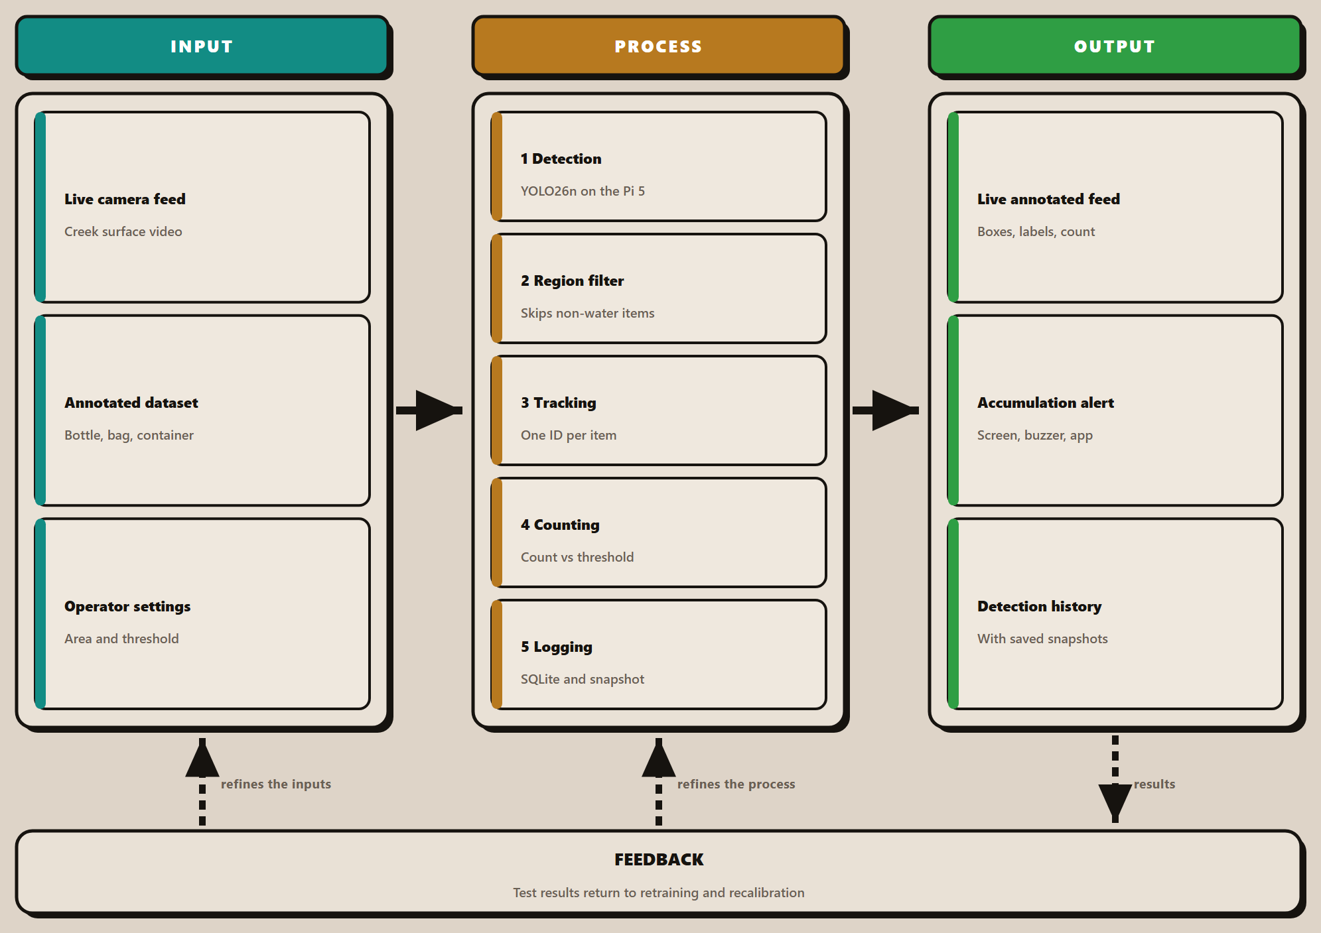
The conceptual framework of Garbage-Guard is illustrated in Figure 1, and is structured in an IPO or Input-Process-Output model with a feedback path. The process column is expanded to show all of the system block, because these are what make this system a detector, not just a frame labelling system.
There are three inputs to the system. The first is the live camera feed from the network camera mounted above the creek surface that provides frames on an ongoing basis, not on a schedule. The second is the annotated data set which is divided into three classes (bottles, bags and food containers). The third one is a set of operator settings: the region of interest drawn on the water, the number of items to be accumulated (default is twenty), and the alert preferences.
The processing is done in four stages on a Raspberry Pi 5. Detection is done by a YOLO26n convolutional network that is exported to NCNN format that the board runs fastest. Tracking will allow and maintain one identity per object, frame to frame – they will no longer flitter in and out of view, but have a solid box with a label. Any detection that is not in the traced water area is then discarded by the region filtering, and so are not included in the count, which helps to prevent the inclusion of fixed objects at the edge of the bank. Counting involves taking the number of accumulated objects present in the area of each frame, smoothing it as the median of the last 15 frames (whereby it is not moved by a single object that is missed or falsely detected), and comparing it against the threshold. Logging writes each alert, together with its snapshot, to a local database and synchronizes it to the cloud.
The point to emphasize is the region filter and the smoothed count, this is what takes this detector over to a monitoring system. If a detector detects twenty bounding boxes in one frame, it doesn't mean that twenty objects are there, because one frame may have a false detection or may not detect an object, and a system that can't exclude the bank will report a concrete wall as garbage while it is in frame.
The system has three outputs. The live annotated feed with the bounding boxes, class labels and running count are displayed on the touchscreen dashboard. An accumulation alert is triggered on screen, on the buzzer and sent to the Android app when the threshold is exceeded. All recorded events are kept in a detection history that can be searched, with a snapshot saved for each, this is how a reading can be checked afterwards.
Evaluation is based on standards of ISO/IEC 25010:2023: functional suitability, performance efficiency, and usability, for evaluating the input and process phases. A weak per-class results lead to further annotation and retraining, while latency measured during operation dictates the frame sampling rate, and comments from the operator on the interface are used to guide design of the dashboard. The feedback path is illustrated, since this is what occurred in this study: The detection model is trained using multiple versions and the accumulation threshold is not predetermined but is tuned on site.

2.2 Review of Related Literature and Studies

Sx

Environmental Garbage Issues in Philippine Waters
Based on the UNEP (2023) or United Nations Environment Programme, World Bank (2022), and Acot et al. (2022), urban waterways such as rivers and creeks play a critical role in the lives of people living in urban centers.
However, due to the effects of rapid urbanization and an ever-increasing population, the amount of solid garbage generated has increased over the years, particularly in the Philippines.
The researchers emphasized that a huge volume of garbage generated in the urban area ends up in the waterway due to inappropriate garbage disposal mechanisms. The researchers’ study results revealed that waterways are considered accumulation points for solid garbage originating from the surrounding communities.
However, the researchers’ study focused on the garbage management policies and environmental effects rather than the technological aspect. These researchers’ studies are related to the present research because they emphasized the need to monitor garbage pollution in the waterway, such as a creek.
Figure 2
Cumulative Contribution of Rivers to Global Plastic Emission
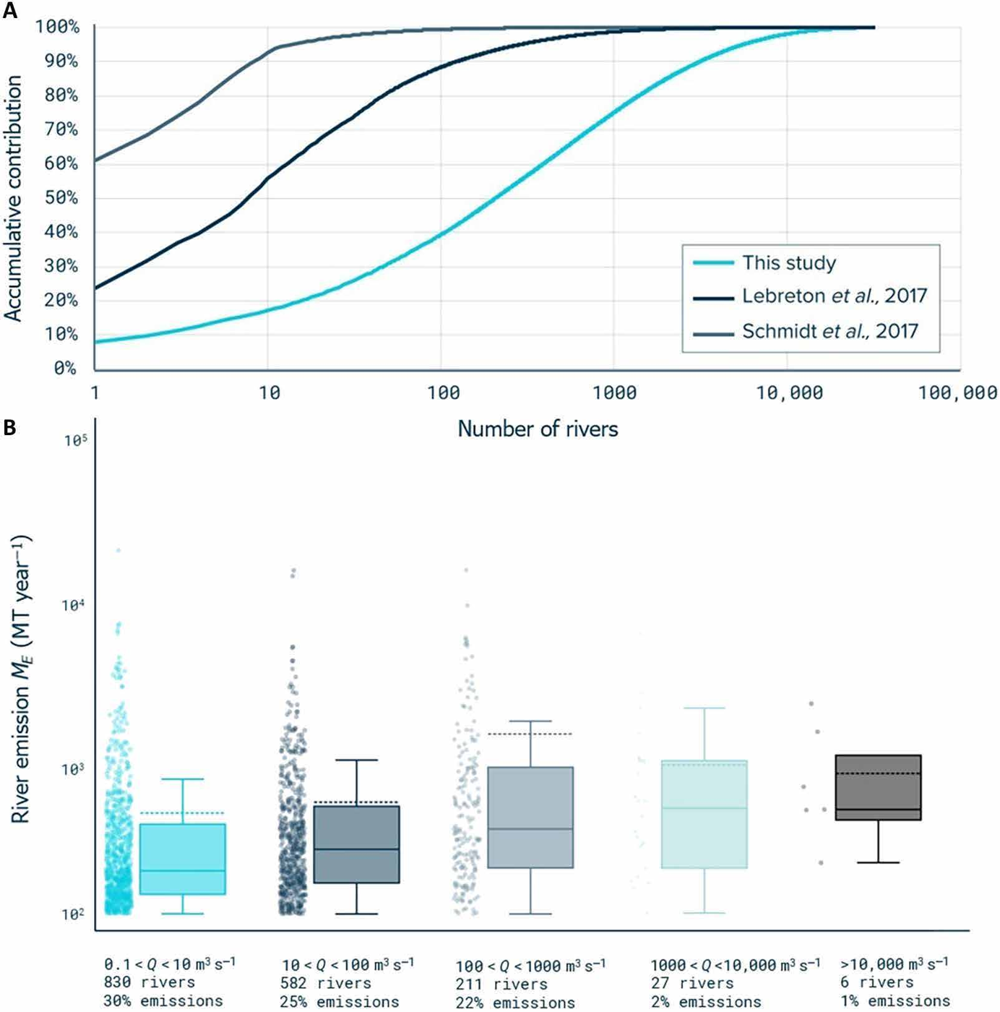
Note. From “More than 1000 rivers account for 80% of global riverine plastic emissions into the ocean,” by L. J. J. Meijer, T. van Emmerik, R. van der Ent, C. Schmidt and L. Lebreton, 2021, Science Advances, 7(18). CC BY-NC.

Rivers as the Pathway for Ocean Plastic (Meijer et al., 2021)
According to Meijer et al. (2021), rivers are the pathways that check the transportation of garbage from land to ocean. The research showed global modeling and data finding of environmental data to see sources and pathways of garbage in oceans. The research findings saw that a serious amount of garbage was entering the ocean coming from rivers that are mainly in heavy populated environments. However the research was heavily leaning on data analysis and modeling techniques, which is not effective in checking groups of garbage in creeks. This research is similar to the current study, because it shows the dangers of rivers in the transportation of garbage materials.

Mismanaged Plastic Waste and Urban Flooding (MacAfee & Löhr, 2023)
MacAfee and Löhr (2023) checked the interaction of non-organized plastic waste (MPW) and flooding in rapid urbanization and climate change. The review indicates that the rise in the amount of plastic waste in drain channels increases the risks of flooding, especially in coastal cities MacAfee and Löhr (2023). The limitation of the research is based on the fact that it is based on existing literature without offering technological solutions. The research is relevant in the sense that it emphasizes the need for waste monitoring in the prevention of environmental and social hazards.

Identifying Plastic Waste in Marine Ecosystems (Das et al., 2025)
According to Das et al. (2025), the paper “Plastic Waste in Marine Ecosystems: Identification Techniques and Policy Interventions” reviewed a lot of research papers on marine plastic waste, focusing on techniques and policies that can be intervened. The findings showed that polyethylene and polypropylene are main plastic waste, and the best way to identify plastic waste is by using infrared spectroscopy and AI recognition. The limitations of this research is that it only depended on literature studies and not experiments. The research paper is still relevant to the current study because it showed that waste in water can still be managed.

Wastewater Management in the Philippines (Corpuz, 2025)
Corpuz (2025) saw the issues in wastewater management in the Philippines. The research saw issues in waste management such as a growing population and poor treatment facilities. This results in wastewater not being treated, being discharged to water bodies. This research used policy review and environmental review as a research method. The limitation of this research is that there is a lack of technology in monitoring wastewater. This is similar because it shows the importance of water checking systems, an objective of Garbage-Guard.

Solid Waste Management and Economic Growth (Ella et al., 2022)
Figure 3
Municipal Solid Waste against Gross Domestic Product per Capita
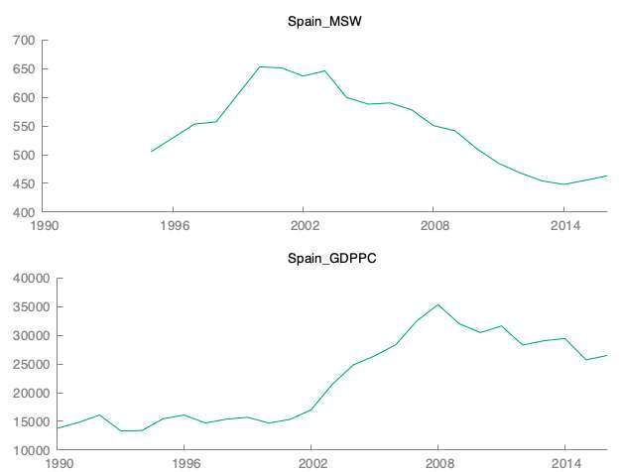
Note. From “The impact of solid waste management to the economic growth in selected OECD countries and Philippines,” by D. M. Ella, D. M. Lim, B. Lu and R. Cabauatan, 2022, Journal of Economics, Finance and Accounting Studies, 4(1). CC BY.
The study by Ella et al. (2022) on the relationship between municipal solid waste (MSW) management and economic growth in selected OECD countries and the Philippines revealed that MSW has a positive effect on GDP per capita. However, the effect of recycling varies by country. The limitations of the study are its concentration on statistical data rather than real-time waste management. This study is similar because it shows the importance of managing waste.

Plastic and Microplastic Waste in Southeast Asia (Ng et al., 2023)
Figure 4
Weathering and Fragmentation of Plastic in the Marine Environment
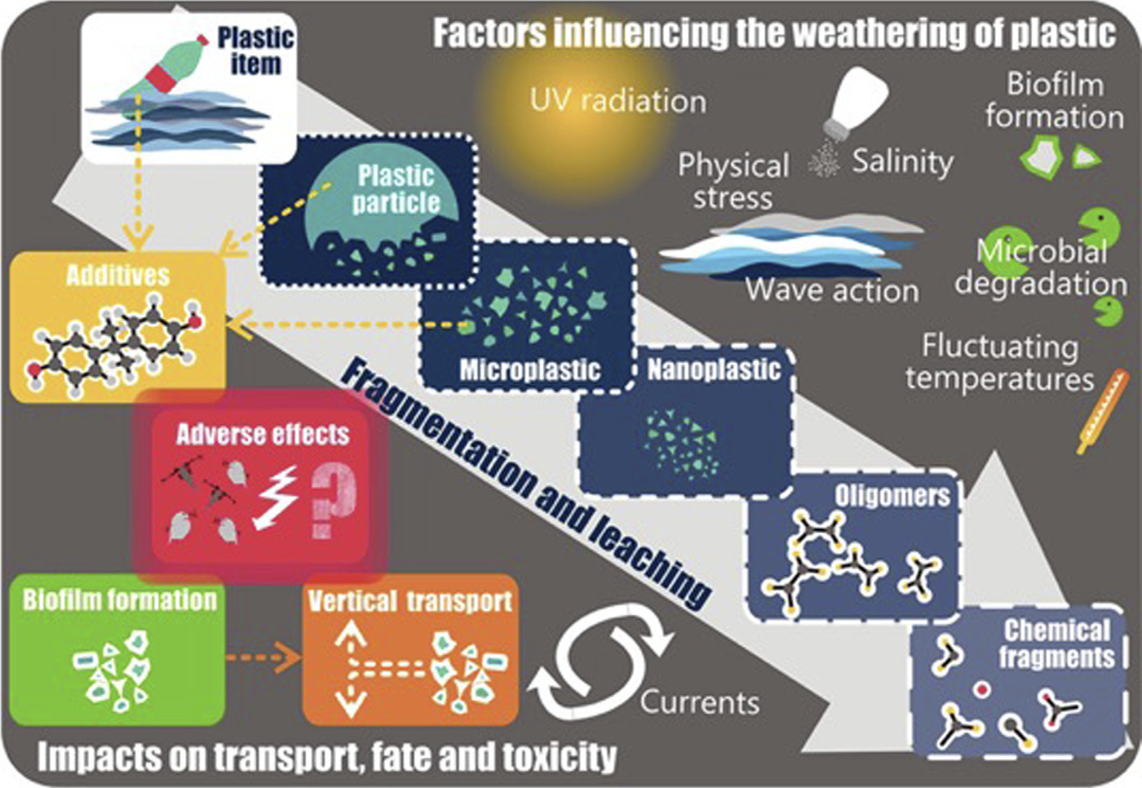
Note. From “Plastic waste and microplastic issues in Southeast Asia,” by C. H. Ng et al., 2023, Frontiers in Environmental Science, 11. CC BY.
According to Ng et al. (2023) on pollution in Southeast Asia, it is obvious that it lacks structure and poor waste collection practices are bringing an increased level of plastic pollution in water sources. The research earns a review approach and limited citations in data coverage and is dependent on secondary sources. The research is relevant in that it highlights the importance of monitoring and detection of plastic pollution, in which Garbage-Guard helps through computer vision.

Computer Vision Systems

Floating Object Detection on Edge Hardware (Li et al., 2024)
Figure 5
Floating Objects Detected on a Water Surface
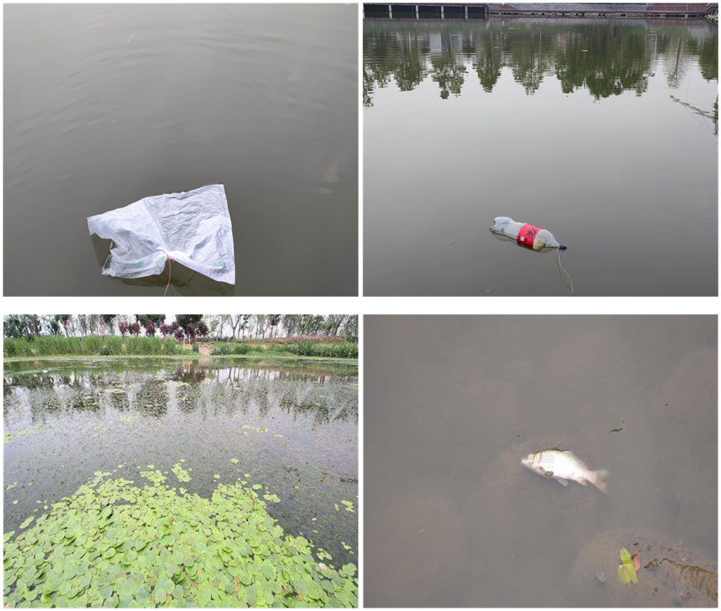
Note. From “Detection of floating objects on water surface using YOLOv5s in an edge computing environment,” by H. Li et al., 2024, Water, 16(1), 86. CC BY.
Li et al. (2024) addressed the problem this study also faces, which is running a detector on hardware small enough to sit beside the water rather than in a server room. Their improved YOLOv5s model raised detection accuracy by 15.7 per cent over the baseline, cut false detections on small targets by 83 per cent, and sustained 33 frames per second on an edge device. Two findings carry directly into Garbage-Guard. The first is that a small YOLO variant is sufficient for floating-object detection, which supports the choice of YOLO26n over a heavier model. The second is that accuracy is lost on small and distant objects, which matches the weakness this study observes at the creek, where floating bags are the least reliably detected class.

Computer Vision Detection and Visual SLAM (Chen et al., 2024)
Figure 6
Success Rates of Visual Tracking Algorithms on a Benchmark Set
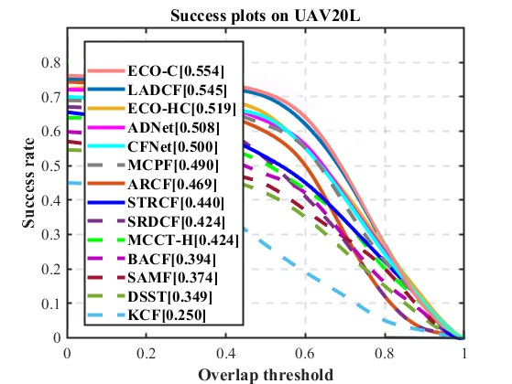
Note. From “A survey of computer vision detection, visual SLAM algorithms, and their applications in energy-efficient autonomous systems,” by L. Chen et al., 2024, Energies, 17(20), 5177. CC BY.
According to the study of Chen et al. (2024), computer vision serves as a foundational element in the realm of intelligent systems and AI technologies. It can effectively replace traditional sensors as the primary source of data input, acting as a pair of intelligent "eyes" that can more adeptly process data sources to drive a range of unmanned operations, such as autonomous driving, obstacle avoidance, and detection tracking. This study is relevant to researchers’ study as we integrate with computer vision to detect waste in creeks in real time.

Detecting and Tracking River-Floating Waste (Nunkhaw & Miyamoto, 2024)
Figure 7
Detection and Tracking Pipeline for River-Floating Waste
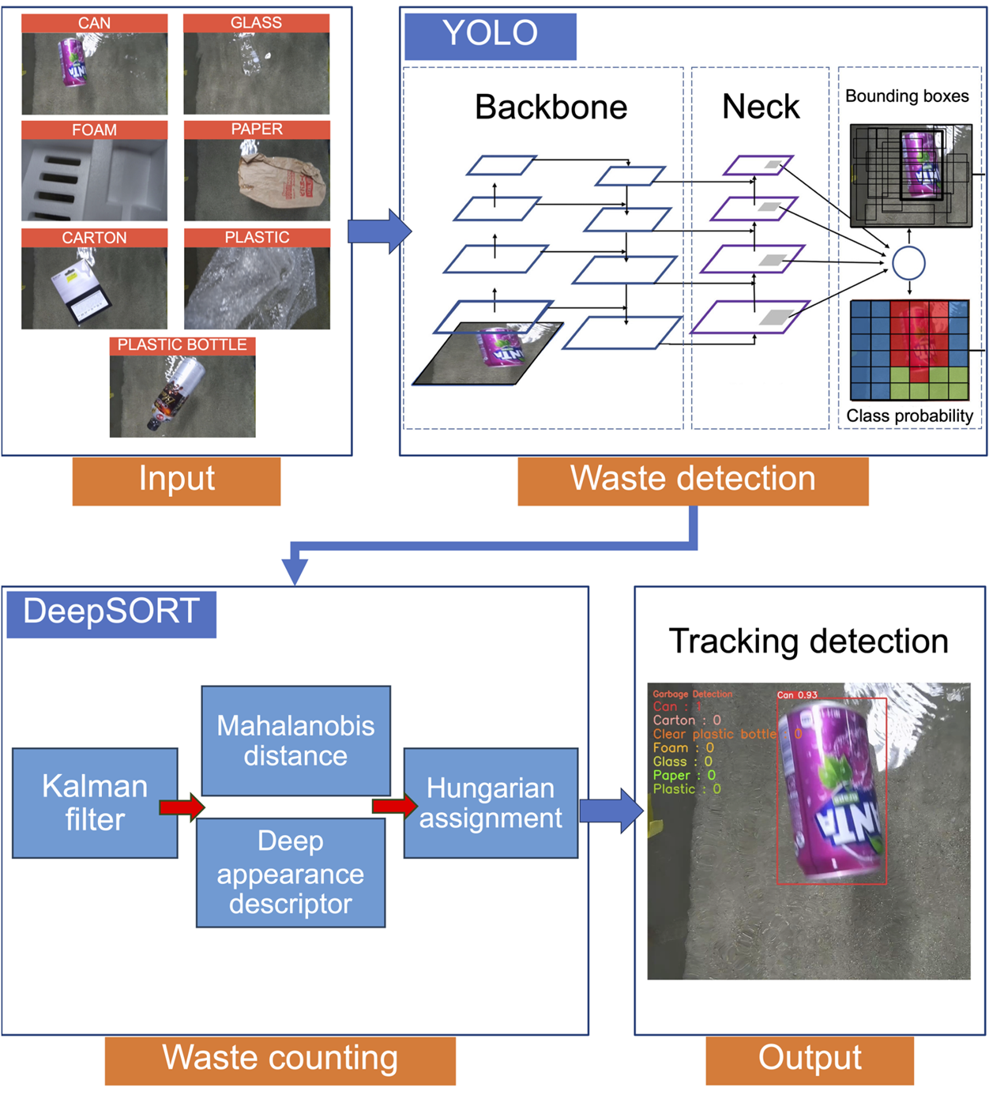
Note. From “An image analysis of river-floating waste materials by using deep learning techniques,” by M. Nunkhaw and H. Miyamoto, 2024, Water, 16(10), 1373. CC BY.
Nunkhaw and Miyamoto (2024) combined a YOLOv5 detector with DeepSORT tracking to analyze river-floating waste, reporting a mean average precision at or above 88 per cent and roughly 80 per cent accuracy across three scenarios. The closest to the method used here that is published is theirs, which makes it clear that detection alone is not sufficient on moving water. If an item is moving around the frame, it should be a single identity in every subsequent frame, otherwise it is counted again if it appears in each frame. Garbage-Guard comes to the same conclusion and to the same solution, which is to replace DeepSORT with ByteTrack. River Waste Detection in Urban Canals (Nunkhaw et al., 2025)
Figure 8
Detection Accuracy in the Laboratory Compared with the Field
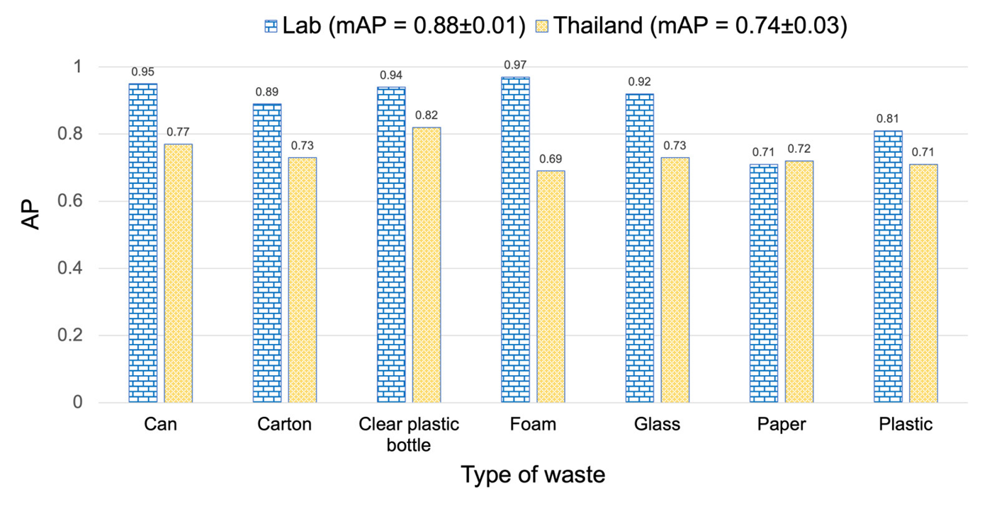
Note. From “Enhancing river waste detection with deep learning and preprocessing: A case study in the urban canals of the Chao Phraya River,” by M. Nunkhaw, D. Chitwatkulsiri and H. Miyamoto, 2025, Water, 17(22), 3193. CC BY.
Nunkhaw et al. (2025) extended that work to the urban canals of the Chao Phraya River, training a YOLO detector on laboratory flume images and then adapting it to real canal conditions through a preprocessing pipeline. The study bears on Garbage-Guard in two ways. It is set in Southeast Asian urban waterways, where waste composition and water conditions resemble a Metro Manila creek more closely than European or North American river studies do. It also documents the gap between performance on controlled images and performance in the field, which is the same gap this study reports between its full test partition and its creek-only subset.

An Open Dataset for Floating Litter Detection (Jia et al., 2023)
Figure 9
Floating Litter Images with True and Predicted Labels
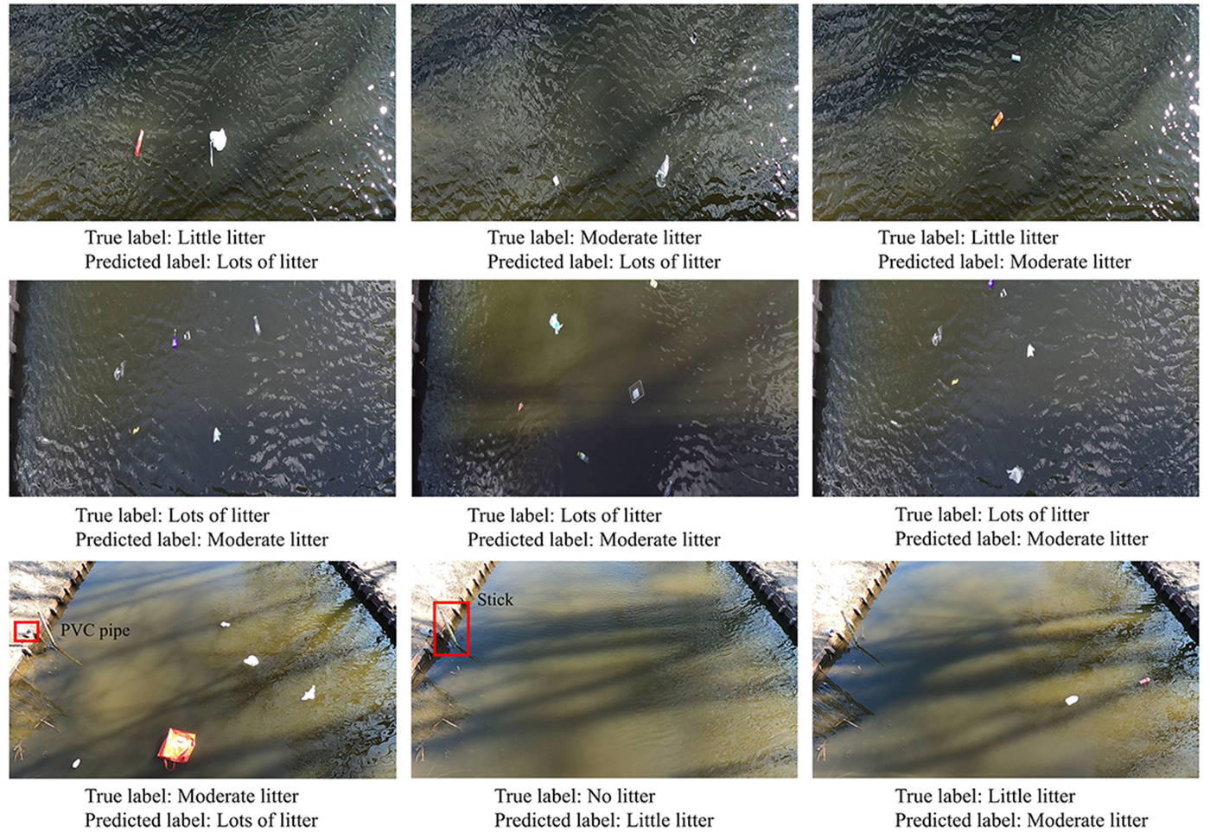
Note. From “Advancing deep learning-based detection of floating litter using a novel open dataset,” by T. Jia, A. J. Vallendar, R. de Vries, Z. Kapelan and R. Taormina, 2023, Frontiers in Water, 5. CC BY.
To overcome the lack of public training data for floating litter detection, Jia et al. (2023) created an open training data set of floating litter and tested the detection performance that the data set could contribute. The issue they present is the one that drove the data collection for this study: there was not an available dataset of images that would match the type of wastes being encountered in the creeks of the Philippines. Their work presents a published explanation to why they chose to build their own dataset as opposed to taking an already existing one and adapting it.

Segmentation Compared with Detection for Floating Macroplastic (Kataoka et al., 2024)
Figure 10
Ground Truth Compared with Model Output for Three Waste Classes
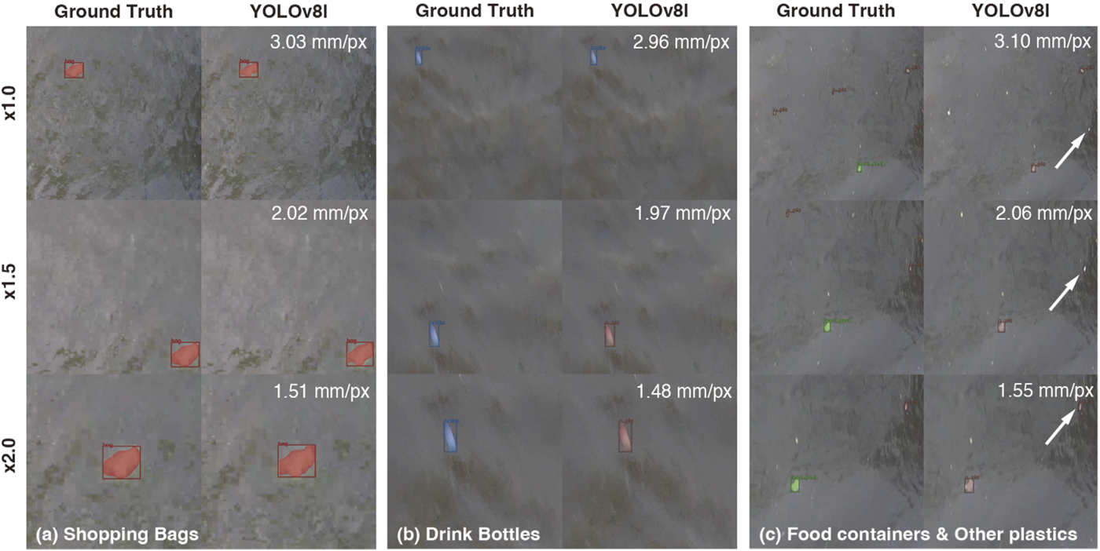
Note. From “Instance segmentation models for detecting floating macroplastic debris from river surface images,” by T. Kataoka, T. Yoshida and N. Yamamoto, 2024, Frontiers in Earth Science, 12. CC BY.
Kataoka et al. (2024) compared instance segmentation models for floating macroplastic in river surface images. Segmentation returns a precise outline of each object rather than a rectangle around it, which is more informative but considerably more expensive to compute. Their results support the decision taken here to use bounding-box detection instead. For counting accumulation against a threshold, what matters is the position and identity of an item rather than its exact outline, and the computation saved is what allows the model to run on a Raspberry Pi at the waterside.

Classifying Waste Fragments with Convolutional Features (Nežerka et al., 2023)
According to the study of Nežerka et al. (2023), to address improper sorting of construction and demolition waste that leads to significant environmental and economic implications, they developed a machine-learning-assisted procedure for recognizing construction and demolition waste fragments using a RGB camera. It resulted in an overall 85.9%, offering a pathway for efficient and accurate waste sorting. It can be relevant to researchers’ study as it relates to detecting waste using computer vision.

Lane Detection under Varying Light (Al Noman et al., 2022)
According to the study of Al Noman et al. (2022) "A computer vision-based lane detection technique using gradient threshold and hue-lightness-saturation value for an autonomous vehicle" the system uses computer vision-based technologies to identify road lines. The left and right lanes on the roads are determined via sliding window searching technique. The system works with 96% accuracy and the positive rate is 0.640%. The accuracy and the efficiency of the system could be developed by increasing computer features and applying deep learning algorithms along with the proposed study.

Object Detection in Overhead Imagery (Kang et al., 2022)
According to Kang et al. (2022), computer vision technology has enhanced the processing of objects in high-resolution overhead images taken by drones, airplanes, and satellites. The technology has been applied in real-world applications like crop analysis, economic analysis, and disaster tracking. Despite the advancements, object detection in overhead images is still a challenge due to the volume of images, resolution, size of objects, and complexity of the background.
Figure 11
Overhead Imagery of the Kind Used for Object Detection
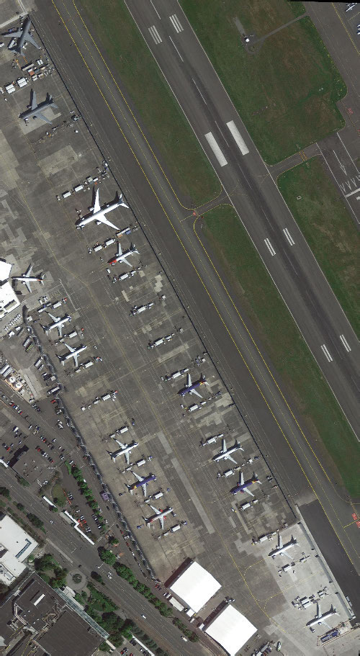
Note. From “A survey of deep learning-based object detection methods and datasets for overhead imagery,” by J. Kang, S. Tariq, H. Oh and S. S. Woo, 2022, IEEE Access, 10. CC BY.

A Review of YOLO Versions for Object Detection (Murat & Kiran, 2025)
Similarly, Murat & Kiran (2025) described that object detection algorithms have undergone a tremendous transformation with the application of deep learning technology. Among the most popular algorithms is YOLO, which is famous for its fast and accurate real-time object detection. The researcher has reviewed the various versions of YOLO, including YOLOv1 to YOLOv11, and described the advancements in the architecture and performance of the algorithm.

The Internal Architecture of YOLOv8 (Yaseen, 2024)
Figure 12
Architecture of the YOLOv8 Detector
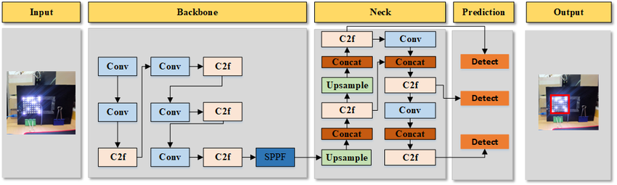
Note. From “What is YOLOv8: An in-depth exploration of the internal features of the next-generation object detector,” by M. Yaseen, 2024, arXiv. CC BY.
Moreover, Yaseen (2024) has examined YOLOv8 and described the advancements of the algorithm over the previous versions. The algorithm applies advanced architectures such as CSPNet and FPN+PAN, along with an anchor-free technique, to enhance the feature extraction and multi-scale detection. The algorithm has been evaluated using various datasets, including Microsoft COCO, which shows the accuracy and real-time detection capabilities of YOLOv8.

Smart Environmental Monitoring Systems

Real-Time Environmental Monitoring with IoT Sensors (Narayana et al., 2024)
In the research conducted by Narayana et al. (2024), environmental conditions are made up of both living and non-living components that affect human life. The non-living components include land, water, stones, atmosphere etc., and living components include organisms like plants, woodlands, fisheries and wildlife etc. Environmental parameters, like temperature, humidity, pressure, air quality, greenhouse gases, wind speed and direction, rainfall, soil pH, soil moisture, water availability, light, turbidity, etc., influence people's lives, especially in the case of workers who practice activities such as agriculture, navigation, traveling, and mining.
In addition to that, to address the issue of monitoring environmental variables and to mitigae the challenges that come with monitoring environmental parameters, IoT technology was used to develop IoT-based smart environmental monitoring systems. This technology uses microcontrollers and other technologies to monitor environmental parameters from different locations and send the data to a website for monitoring and observation remotely using IoT technology. IoT technology is a dynamic system that observes and responds to environmental variables and conditions (Narayana et al., 2024)

Sensors in Smart City Systems (Zeng et al., 2024)
In the study of Zeng et al. (2024), the integration of IoT technology into smart city systems has several advantages in the management of the environment, as it allows real-time monitoring of important parameters such as air quality, water quality, noise levels, soil quality, and others. This has enabled city administrators to proactively manage the resources of the city in a cost-effective manner. These parameters have collectively proven the importance of IoT sensors in achieving sustainability in the environment.

IoT and Artificial Intelligence in Air Quality Monitoring (Garcia et al., 2025)
Figure 13
Selection of Studies for a Systematic Review of Air Quality Monitoring
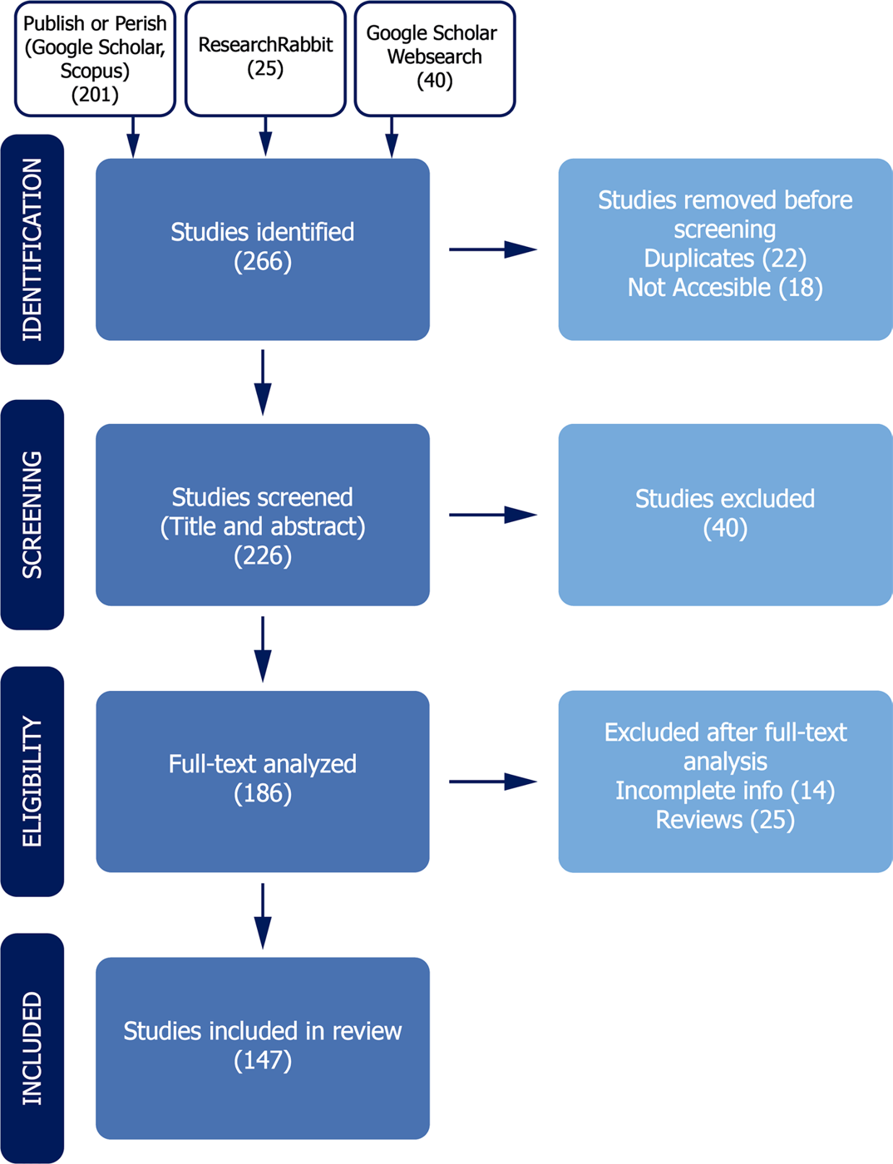
Note. From “Advancements in air quality monitoring: A systematic review of IoT-based air quality monitoring and AI technologies,” by A. Garcia, Y. Saez, I. Harris, X. Huang and E. Collado, 2025, Artificial Intelligence Review, 58. CC BY.
Expanding on these capabilities, Garcia et al. (2025) show how Internet of Things (IoT) technologies have greatly improved environmental monitoring by allowing a network of low-cost sensors to continually produce large amounts of real-time data on air quality. This is further enriched by using these IoT systems with the Artificial Intelligence techniques like machine learning and deep learning. This assists to ensure as accurate an environmental assessment as possible. IoT-based monitoring system can monitor various air quality parameters like PM, CO₂, NO₂, ozone, VOCs etc. This makes them an efficient means of conducting a thorough surveillance of the environment. The integrated IoT/artificial intelligence-based systems are evident examples of how these systems can enhance the decisions made with respect to environmental management.

Machine Learning and IoT for Pollution Prediction (Gryech et al., 2024)
In the recent literature of Gryech et al. (2024), it has been observed that there is a rising trend towards the inclusion of IoT technologies with machine learning methods for better outdoor air pollution prediction and forecasting. Though the traditional air pollution stations are accurate, the high cost of these stations has encouraged the development of IoT-based low-cost sensors, along with machine learning methods that are capable of predicting the levels of outdoor air pollution through time-series, feature-based, and spatio-temporal methods, although the limitations of the lack of diversity in the data and the context-specific features have to be addressed, as identified by the recent literature.

Urban Flood Monitoring with LoRaWAN Sensors (Te et al., 2024)
Figure 14
Water Level and Pressure Recorded during a Rainfall Event
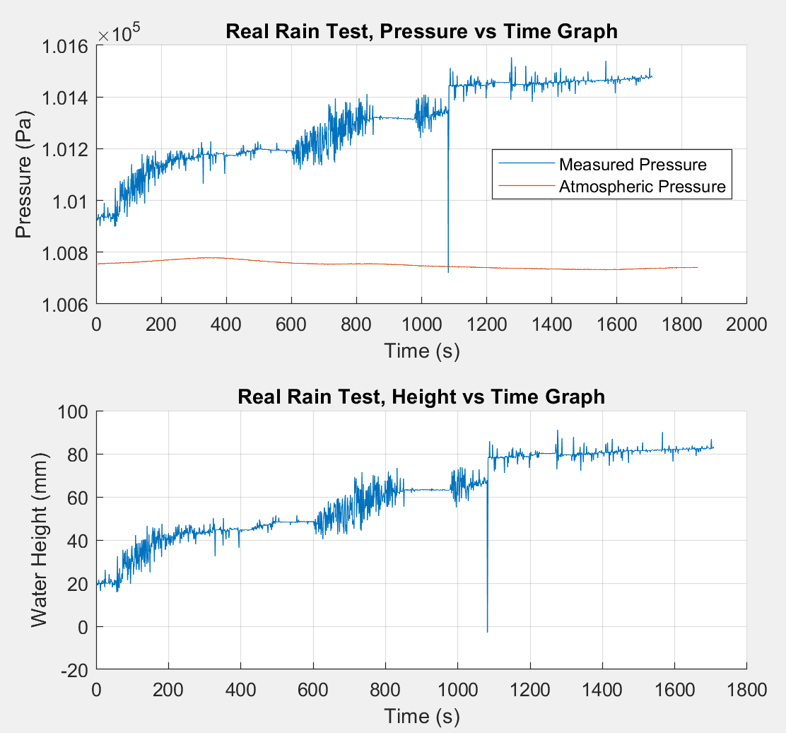
Note. From “A smart IoT urban flood monitoring system using a high-performance pressure sensor with LoRaWAN,” by M. C. L. Te et al., 2024, HighTech and Innovation Journal, 5(4). CC BY.
One of the significant environmental issues experienced in the Philippines has been flooding, which has been attributed to monsoon rains, the topography of the area, and inadequate drainage systems. This has been a major cause of loss of lives and properties, especially in the urban area. In order to address the issue of delay associated with flood monitoring, Te et al. (2024) proposed the development of a smart IoT-based flood monitoring system for an urban area. This would entail the incorporation of efficient pressure sensors, LoRaWAN, and solar power. From the reviewed background of the research, it is clear that there is a need to utilize IoT to address the issue of disaster, as it would allow for efficient monitoring to enhance the flood response strategy (Te et al., 2024).

Secured Flood Monitoring and Forecasting (Arante et al., 2025)
Figure 15
Neuro-Fuzzy Network for Flood Forecasting
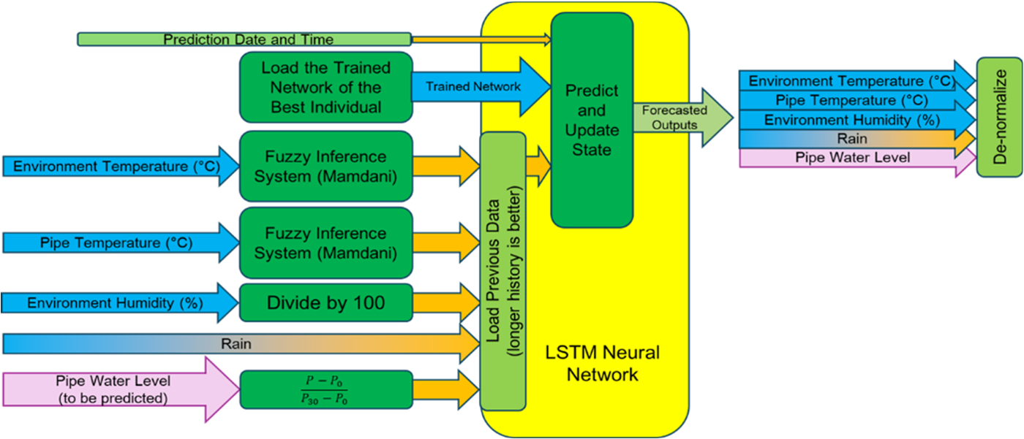
Note. From “Development of a secured IoT-based flood monitoring and forecasting system using genetic-algorithm-based neuro-fuzzy network,” by H. R. C. Arante et al., 2025, Sensors, 25(13), 3885. CC BY.
The monitoring and forecasting of floods in the Philippines are important due to the occurrence of heavy rains and typhoon scenarios, which cause the rapid rise of water levels. In this regard, Arante et al. (2025) contextualized their research by highlighting the limitations of the existing flood monitoring systems, which are not effective in the Philippines, and the need to develop a secure IoT infrastructure to transmit data on water levels to aid in the prediction of floods. The authors proposed a neuro-fuzzy LSTM machine learning model to improve the accuracy of flood event prediction, which is a form of smart environmental monitoring system in a water-related disaster scenario.

2.3 Review of Related Patents
Table 1
Table of Related Patents
Patent Title | Author | Adopted Feature | Enhanced Feature
Garbage Detection Method, Related Equipment and Device | Li & Wang (2020) | Image recognition to detect garbage | Enables automatic garbage detection in areas.
Vision garbage classification system based on TensorFlow | Wu et al. (2019) | The AI system classifies garbage usingTensorFlow. | Using similar A system, it improves garbage recognition using deep learning model like YOLOv8
Smart City Waste Collection and Management using IoT | Chordiya et al. (2020) | IoT Sensors monitor garbage compiling systems. | Using a camera for real-time monitoring of garbage
Cleaning Unit Using Deep Learning for Floating Trash Detection | Hyun-dong et al. (2019) | Uses object detection to identify trash | Enhances garbage identification using AI algorithms.
Drainage monitoring apparatus and system | Campbell et al. (2022) | Water level sensors monitor drainage conditions and detect faults. | Detects garbage as a cause of drain blockage in waterways.
System for monitoring water drainage | Den Hartog & Voncken (2017) | Sensors monitor water levels in drain systems. | Detects water blockage and water conditions.
Detection and monitoring of waste disposal using artificial intelligence | Liu et al. (2022) | AI monitors garbage in the environment | Tracks garbage data using automated analysis.
Flood warning system | Torres et al. (2024) | Sensors detect rising water levels. | Alerts user when garbage buildup cause flooding
Method and System for Flood Early Warning in Smart Cities Based on the Internet of Things | Shao et al. (2023) | IoT sensors monitor rainfall and water levels | Garbage detection as an early indicator of flooding risk
Apparatus and Method for Waste Monitoring and Analysis | Balachandran & Talavera (2023) | Sensors and cameras monitor garbage levels in containers. | Automates garbage detection using Computer Vision analysis
Figure 16
Garbage Detection Method, Related Equipment and Device
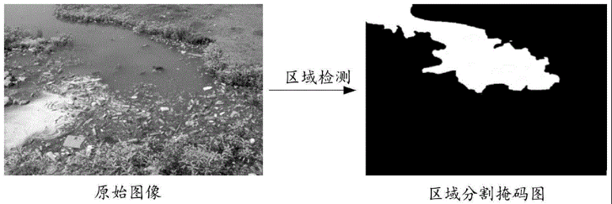
In Figure 16, Chinese researchers have made a garbage detection method using image recognition. The system takes pictures of monitored rivers and processes them to find garbage.
This technology can be used in different urban areas such as lakes and parks. It analyzes captured images to think whether garbage objects are visible in the environment. In this patent’s case, it relates to Garbage-Guard because it can use computer vision to detect garbage, similar to the researcher’s proposed system that detects garbage in creeks.
Figure 17
Vision garbage classification system and classification method based on TensorFlow
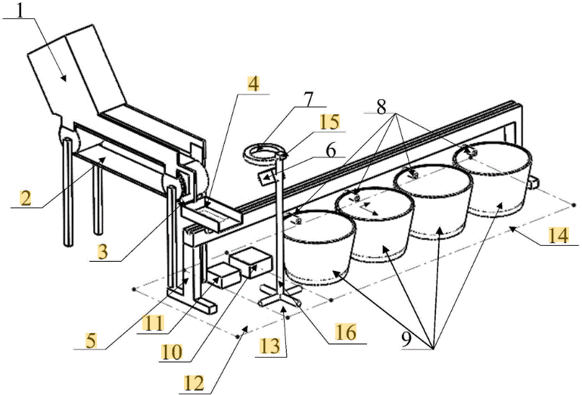
In Figure 17, this patent which uses computer vision, is a Vision Garbage Classification System and Method based on TensorFlow made by Wu et al. (2019). The system uses images of garbage items and puts them into a model trained on garbage images. Methods include data collecting, image processing, and automatic classification of garbage categories.
This patent is similar to the researcher’s present study because it also uses the application of computer vision and machine learning techniques but for automated garbage detection.
Figure 18
WCM-Smart City: WASTE COLLECTION AND MANAGEMENT UNDER SMART CITY USING IOT
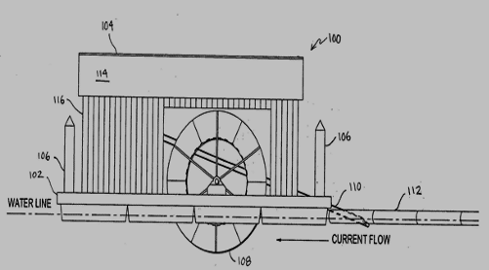
Figure 18 is a patent from Chordiya (2020), describing their study as a waste collection system made for grabbing garbage in rivers and streams. This invention uses a conveyor mechanism that collects waste and transports it into a container. It incorporates monitoring systems with sensors that detect waste levels and can transmit that information to a platform.
This patent demonstrates the use of automatic methods for technologies in managing garbage, it is similar to the researcher’s Garbage-Guard system that aims to find garbage in creeks using computer vision technology.
Figure 19
Cleaning Unit Using Deep Learning for Floating Trash Detection
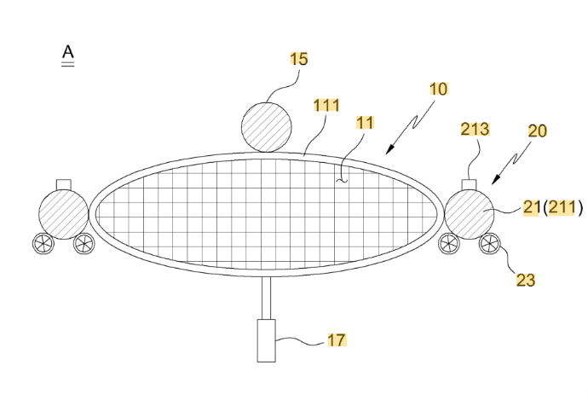
Figure 19 is a similar patent that is related to garbage detection from South Korea. It is a water-surface cleaning unit that uses deep learning technology to detect floating garbage made by Kim et al. (2019). The system integrates a camera module with a deep-learning model which helps in locating garbage on water surfaces. Then, it activates a mechanism that collects the debris from the water.
This type of invention shows how relevant it is to the researchers’ study because it is similar to how artificial intelligence is used for garbage detection in water environments.
Figure 20
System for Monitoring Water Drainage
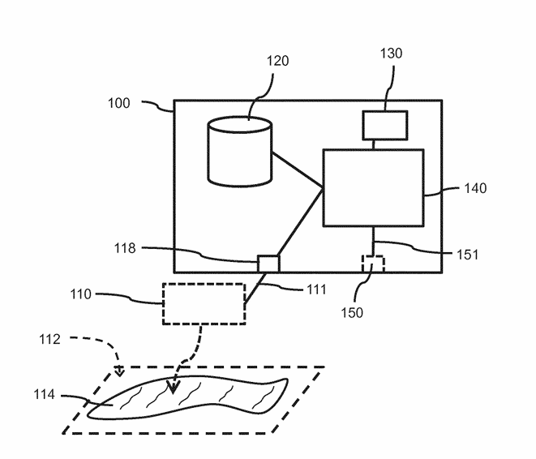
Figure 20, in terms of smart drainage systems, this figure from a patent made by Den Hartog and Voncken (2017) patented a system that is designed to check water drainage environmental sensors. The system collects data from water presence on surfaces and compares it with predicted water drainage conditions based on what happens during rainfall. If the detected water remains longer than usual, the system makes warning signals about potential drainage problems.
This type of technology integrates sensors, weather information, and data processing to check drainage conditions. This type of patent is related to Garbage-Guard because both of the systems required to monitor water environments, by detecting garbage being collected in creeks, which may cause drainage issues.
Figure 21
Drainage Monitoring Apparatus and System
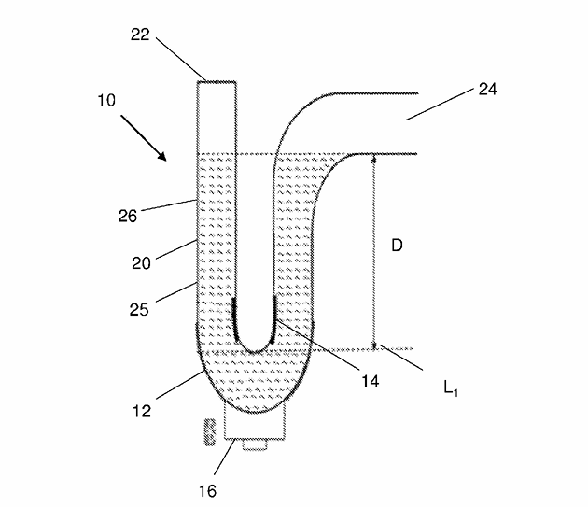
Figure 21 is another patent related to smart drainage monitoring systems, is this patent from Campbell et al. (2022), which showcases a drain monitor apparatus designed to look at water levels within building drainage systems. The invention uses a water trap equipped with a water level sensor that checks the level of water inside the drainage trap. When the water level drops to a specific point, the sensor sends a signal to a system or mobile application that can make audible alerts to inform that there are drainage faults.
This technology is relevant to Garbage-Guard since it is similar to how the systems monitor drainage systems. However, instead of detecting water levels, it detects the various amounts of garbage in creeks using computer vision.
Figure 22
Detection and Monitoring of Waste Disposal Using Artificial Intelligence
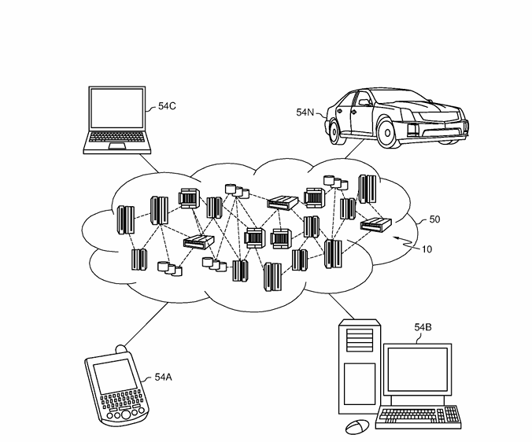
Figure 22 patent by Liu et al. (2022) made an artificial intelligence system for detecting waste in environmental locations, just like natural environments. The system collects images using sensors or cameras and gives them to machine-learning algorithms that check waste objects. Then, the system tracks waste accumulation patterns and finds the location and size of garbage in monitored areas.
This patent is similar to Garbage-Guard’s usage of Artificial Intelligence and image analysis to find garbage in different locations.
Figure 23
Flood Warning System
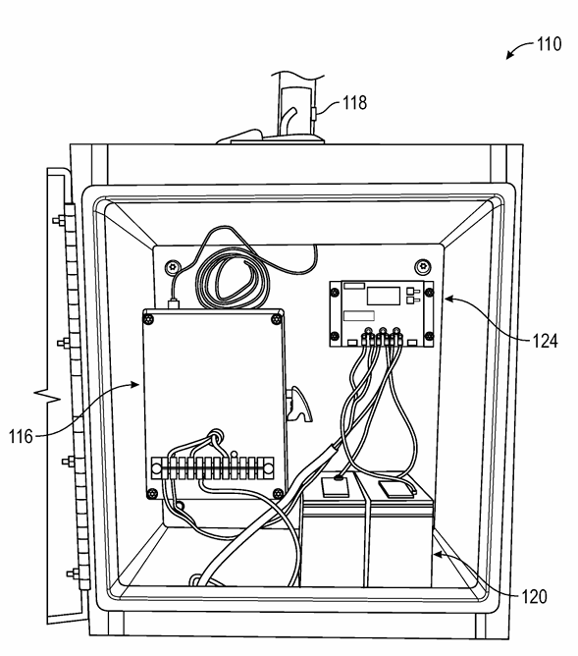
Figure 23 patent by Torres et al. (2024) made a flood warning system to provide early warnings for floods using monitoring systems. It includes multiple of these in monitoring stations near rivers or drainage channels. Each of these are equipped with sensors that monitor water level and rainfall accumulation. That collected data is connected wirelessly to a flood warning station, where it is checked to determine whether the water level exceeds the thresholds. When a flood risk has been shown, the system will make visual alerts that are sent to users through mobile devices.
This patent is useful and similar to Garbage-Guard’s system, since warning systems are important in monitoring the environment and can notify when the creeks are filled with garbage.
Figure 24
Method and System for Flood Early Warning in Smart Cities Based on the Internet of Things
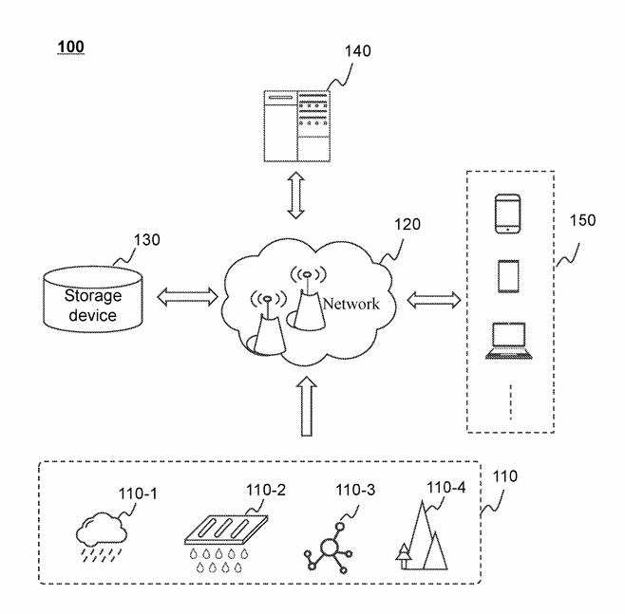
The patent at Figure 24 from Shao et al. (2023), made a smart flood early warning system that has Internet of Things (IoT) with data to detect potential flooding conditions in urban places. This system collects precipitation information from weather stations and combines it with the data from the sensors to estimate water level in specific areas.
This invention is similar to Garbage-Guard where they involve environmental monitoring and alerts.
Figure 25
Apparatus and method for waste monitoring and analysis
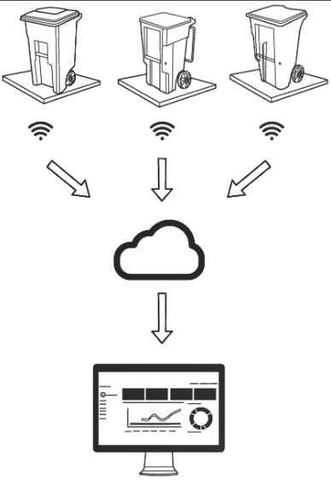
In Figure 25, a patent by Balachandran & Talavera (2023) invented a waste monitoring and analysis system, made for analyzing waste collected in containers. It uses sensors such as load cells and cameras to measure the weight and type of waste material placed inside bins. That data is collected and given to a cloud platform where it can be analyzed. With this information, it can define the pattern of the trash disposals, and make reports about waste generation.
This patent is relevant to Garbage-Guard because it shows how sensor-based systems can monitor and analyze data in real time. The invention focuses on detecting waste garbage collection in creeks using computer vision technology.

2.4 Synthesis of the Review
The literature reviewed in this chapter converges on four points. First, the volume of plastic that enters the ocean through rivers is also very large, a very few rivers account for the majority of the plastic and the highest concentration of plastic is found at the lowest collection sites. Meijer et al. (2021) state that more than 1000 rivers are responsible for 80% of riverine plastic emission, with Southeast Asia (Ng et al., 2023) and the Philippines (Corpuz, 2025) being those where collection infrastructure is not at par. The problem this study addresses is therefore a documented and measured one rather than a local inconvenience.
Second, it's not scalable to manual inspection. Studies, which have attempted to quantify waste in waterways, are dependent on a survey campaign, a satellite pass or a modelled estimate, all of which fail to return a reading for the operator to take action on the same afternoon.
Thirdly, convolutional object detection has reached a certain level of maturity and can handle the task. Murat and Kiran (2025) and Yaseen (2024) report the accuracy and speed improvements of all the YOLO versions over the past 10 years, while Nežerka et al. (2023) demonstrate that convolutional classification is superior to hand-selected feature extraction with waste fragments in particular. Detection of floating waste is not an open research question.
Fourth, the supporting pieces are set up separately. Li et al. (2024) show a ‘Very small YOLO’ (VsYOLO) that runs on an edge device to identify floating objects at a frame rate of 33 fps. Nunkhaw and Miyamoto (2024) combine detection with tracking to ensure that an item passing through the frame is only counted once. Nunkhaw et al. (2025) continue this practice to urban canals in Southeast Asia and report the difference between lab and field. Jia et al. (2023) tackle the lack of public floating-litter data, while Kataoka et al. (2024) compare segmentation with bounding-box detection. Narayana et al. (2024), Zeng et al. (2024) and Te et al. (2024) prove that environmental sensing on a limited hardware platform coupled with real-time alerting is commonplace.
None of the studies examined here draw the components together in the way needed for this project. The waste-detection work classifies images without any time series accumulation. Accumulation work is the work that accumulates items in containers instead of on moving water. The environmental monitoring work alerts based on scalar sensor readings and not on the count of them. Not all of the systems reviewed have an operator trained detector on the edge at creek level, limit count to an operator defined area of water, maintain one identity per item across frames, and trigger a threshold alert on that result. Table 2 presents that gap in reference to what this study posits.

Table 2
Proposed Solution Matrix
Limitation in the examined literature | Representative source | How Garbage-Guard responds
No detection of waste over the time period, only at classification. | Nežerka et al. (2023); Magyar et al. (2023) | The objects in the monitored area are counted, smoothed across 15 frames and compared to an operator-set threshold; thus, the output is a sustained accumulation reading and not a label per frame.
Waterway monitoring requires manual survey or satellite passes, which results in the readings being periodic. | Meijer et al. (2021); Victoriano et al. (2022) | Continuous processing and monitoring of a fixed camera feed, and logging of every event with the time recorded on-site
Counting systems assume a contained, static scene | Balachandran and Talavera (2023) | Region filtering helps to limit the counting within the traced region of water, and tracking helps to maintain a one-to-one correspondence between one floating object and one identity.
Alerting in the environment is based on scalar thresholds on sensors and not visual observation and evidence | Te et al. (2024); Arante et al. (2025) | The alert is based on a visual count and includes a saved snapshot and the reading that triggered the alert can be viewed.
Detection models are published on curated datasets and not deployment conditions | Li et al. (2024); Nunkhaw et al. (2025) | The model is reported on a frozen held-out partition, and a creek-only subset, so field performance is reported separately.

III. METHODOLOGY

3.1 Project Design
Figure 26
Garbage-Guard’s System Architecture
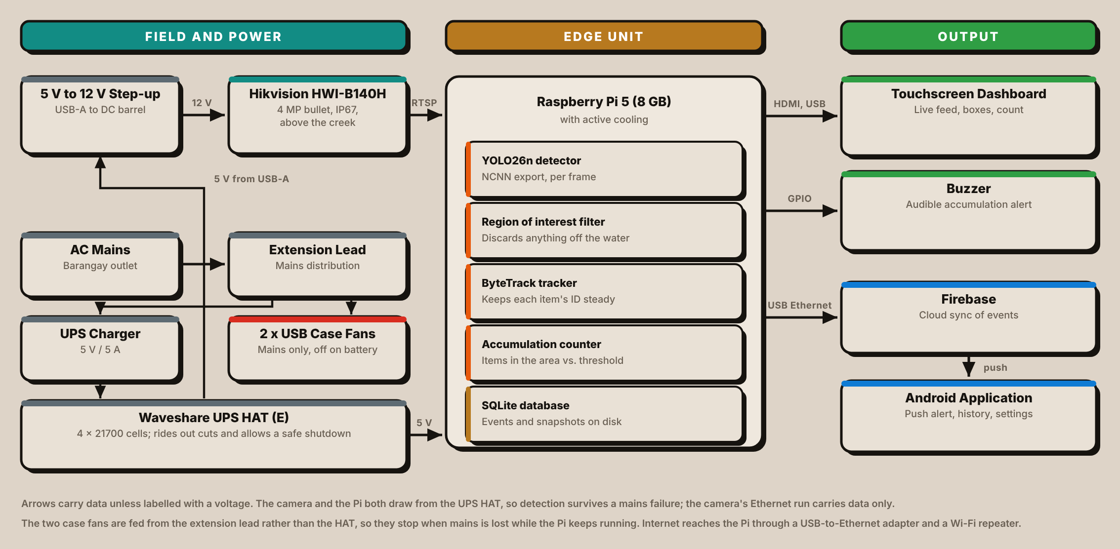
The project design emphasizes the key features, components, and project processes needed to support the goals of the study. It contains hardware and software integration, block diagrams, flow diagrams and sequential operations for the functionality of the system.
The proposed Garbage-Guard prototype should auto-detect floating garbage materials while monitoring a creek. With this, it employed a high-definition CCTV camera wherein real-time videos are being used, then applied the YOLO26 object detection algorithm; thus, able to classify whether the objects floating on the water are bottles, bags, or food containers accurately wherein all these processes are done inside the Raspberry Pi 5 edge computer as seen in Figure 26.
The prototype includes the following components:
- Input: Live video footage of the creek surface recorded by a CCTV camera.
- Processing: A YOLO26n model, exported to NCNN and run on a Raspberry Pi 5, with a region-of-interest filter and ByteTrack tracking, classifies and counts floating solid garbage.
- Storage: Detection and accumulation records are stored in a SQLite database on the unit, with a snapshot for every event, and synchronized to Firebase.
- User Interface: Real-time detections and accumulation alerts are shown on a touchscreen dashboard, sounded on a buzzer and pushed to an Android application.
This will be a real-time system, which will not only support local authorities with insight for enforcement of the environment regulations, but also reduce severe pollution in local water ways. The system immediately feeds back garbage accumulation information to support the communities to manage and be aware of ecological situation. This proactive effort helps to improve water quality, minimize environmental health risks and promote adherence to garbage disposal regulations.

3.2 Block Diagram
Figure 27
System Flow of the Waste Detection System
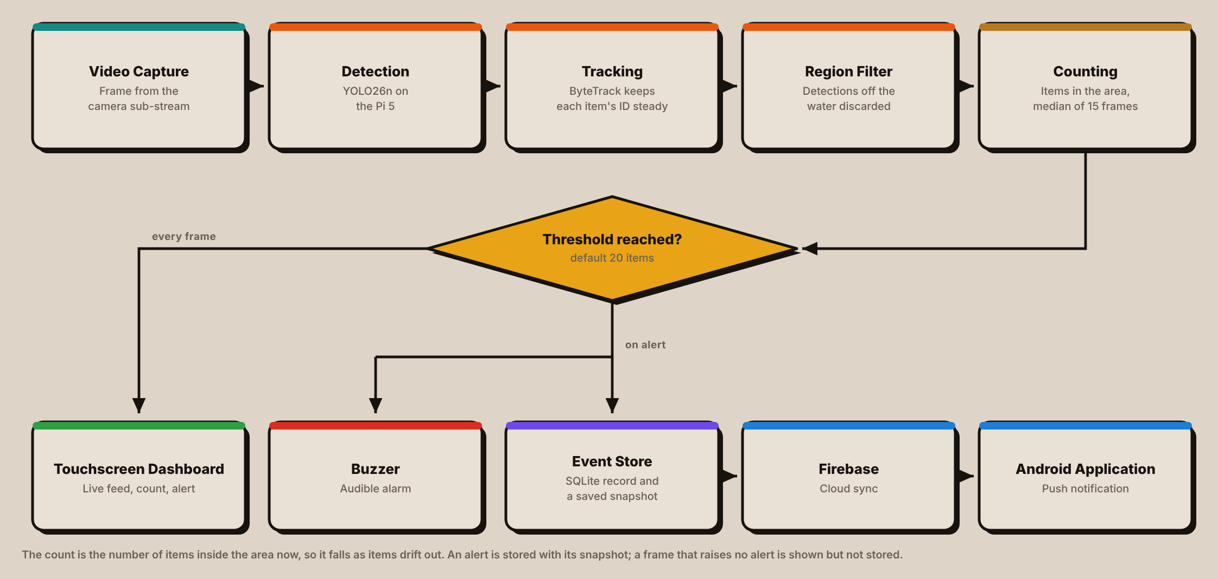
Figure 27 shows the block diagram of the system that integrates the YOLO26 algorithm, edge computing device (Raspberry Pi 5), and CCTV camera, which achieves more efficient real-time garbage detection and data storage.
Once it has been initialized, the camera takes a real-time video of the water surface being targeted. This information is then passed to the main processing unit, a Raspberry Pi 5, which uses the YOLO26 algorithm to process the footage in real-time, categorize floating solid waste, maintain a constant identification of each object, and exclude objects outside the water area being monitored before counting the remaining objects. The system displays the results, annotated in real time, and enables users to see the live dashboard, accumulation alerts and access data. The main processing unit decides whether to alert or not, triggering an alert when a garbage threshold (default is 20) is reached. Furthermore, it securely stores all the garbage data in the local database, including garbage category, time and garbage accumulation for further analysis. It can be seamlessly integrated with hardware (Raspberry Pi 5 and camera) and software (YOLO26), allowing the local communities to monitor and manage environmental hazards safely and efficiently.

3.3 Flowchart
Figure 28
Garbage-Guard’s System Flowchart
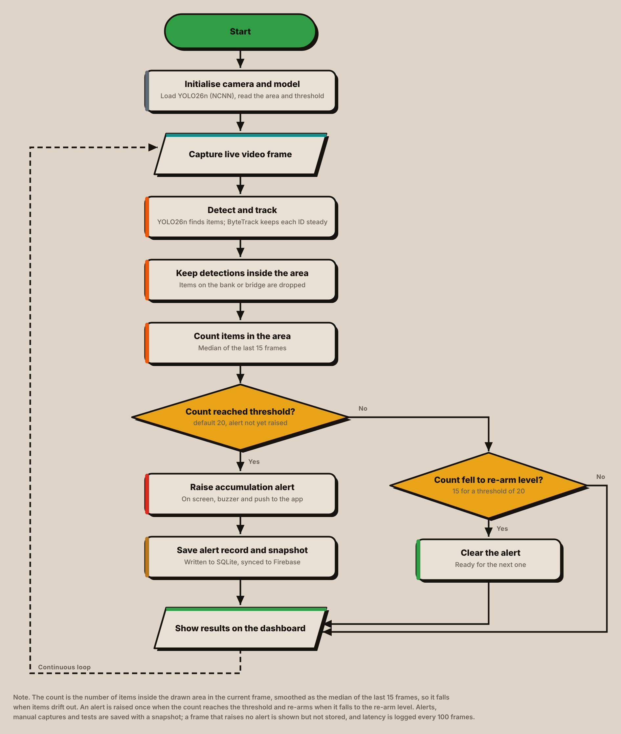
The garbage detection & data management process is shown in Figure 28. It is a process that begins by turning on the camera, initializing the camera, loading the model and the saved monitoring area and threshold. The system then captures a live frame of video and uses YOLO26n to detect floating garbage and returns garbage detections to ByteTrack which maintains a single identity for each piece of garbage which keeps its box/lable constant across different video frames.
Detections outside the region of interest are then discarded, thus preventing objects on the bank or a bridge being counted. The number of items left in the area is tallied and the number is smoothed by taking the median of the previous 15 frames. The count thus is an indication of the current amount of garbage in the area: the more stuff that accumulates the higher the count, and the more stuff that moves away, the lower the count.
In the first decision point the smoothed count is compared with the accumulation threshold, which has a default value of 20 items but can be configured in the dashboard. When the threshold is exceeded, and there is no Accumulation Alert, the system alerts the user on the touch screen, activates the buzzer and sends a push notification to the Android app. The alert is written to the SQLite database with its counts, the totals for each class and an annotated snapshot, and synchronized to the cloud.
The second decision point is whether or not an active alert can be cleared if the threshold is not met. After it has dropped to the re-arm level (20-15), the alert is removed and the system is ready to trigger the next alert. This difference between the two levels prevents a hovering pile from generating a new alert every few seconds.
In each case the marked frame and the frame count are displayed on the dashboard and the procedure is repeated for the next frame. The frames that fire no alert are displayed but not stored; in addition to alerts, a summary of the processing latency is stored every 100 frames, as well as manual captures and test alerts and mutes. The system thus remains continually analyzing new video and the record is kept small enough for a long deployment.

3.4 Component Materials
This section describes the parts that make up one Garbage-Guard unit, divided into the physical components and the software that runs on them. Each entry states what the component is and what it does in this system, since several were chosen for reasons that are not obvious from the part name alone.

Hardware Components

Raspberry Pi 5 (8 GB)
Figure 29
Raspberry Pi 5 Single-Board Computer
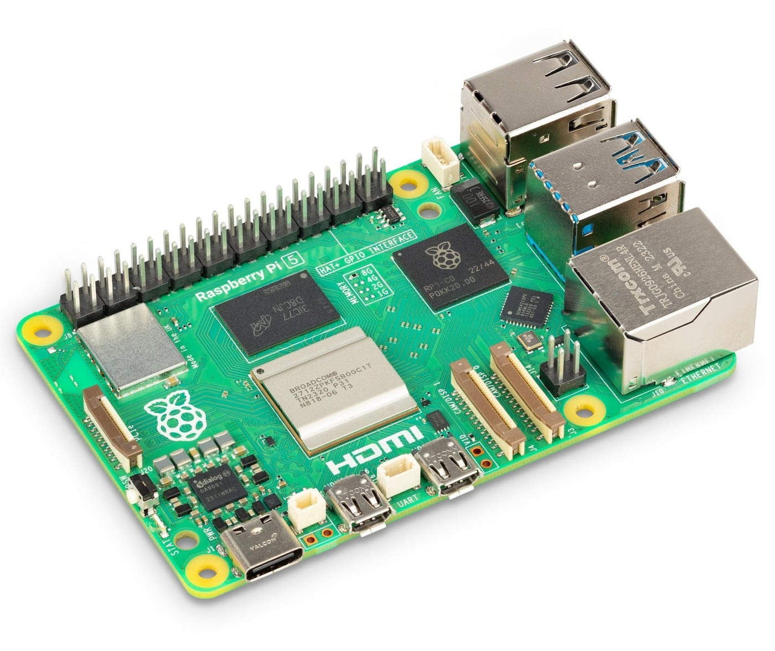
Note. Image from The Pi Hut (n.d.-b).
The Raspberry Pi 5 is a single-board computer based around a quad-core Arm Cortex-A76 processor clocked at 2.4 GHz with 8 GB of memory. Featuring a 40-pin general purpose input/output header, micro-HDMI outputs, USB 3.0 ports, Gigabit Ethernet and a PCIe interface.
It is the whole of the processing side of Garbage-Guard. It downloads the camera's RTSP stream, processes with the detection model, applies the ROI, maintains tracker and accumulation counter, stores in the local database, activates buzzer (GPIO12), publishes dashboard (HTTP) and pushes events to the cloud. The 8 GB version was selected because all three of these, the model, the tracker and the video decoder, run simultaneously with their working buffers in memory.

Hikvision HiWatch HWI-B140H Network Camera
Figure 30
Hikvision HiWatch HWI-B140H Bullet Network Camera
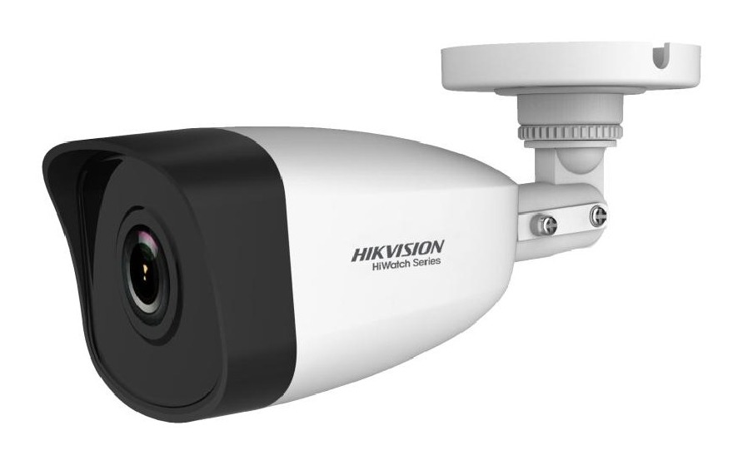
Note. Image from Multi-Line (n.d.).
The HWI-B140H is a 4 MP fixed bullet network camera with a 1/3-inch progressive scan CMOS sensor, which supports up to 2560×1440 at 20 FPS. It has a fixed-focus M12 lens at F2.0, an 850nm infrared illuminator with a maximum off-axis range of approximately 30 m, and an 8 stop (120 dB) wide dynamic range, and is rated as IP67 with an operating temperature range between -30°C to 50°C. It accepts either power over Ethernet or 12V direct current on a 5.5mm coaxial plug, drawing at most 5W on the direct current input (Multi-Line, n.d.).
It is positioned above the creek and pointed along the surface of the creek and it is the only sensor in the system. This is the one feed from which everything Garbage-Guard provides is based, and therefore the IP67 rating and the wide temperature range is of significance for an outdoor deployment. Since the region of interest is traced over the camera's actual view it is mounted first and the region is drawn second, the other way around is not correct.
The camera operates from a 12V input power source and not from a power over Ethernet (PoE) cable, which is used solely for data transfer. Garbage-Guard reads the sub-stream of the camera, not the main stream. The sub-stream is 640 x 480 or 640 x 360, which is a handy match: the size the Pi camera accepts for frames is the same as the size the detection model was trained to detect, rather than down-scaling a 1440p stream on every frame.

Waveshare UPS HAT (E)
Figure 31
Waveshare UPS HAT (E) with Four Battery Bays
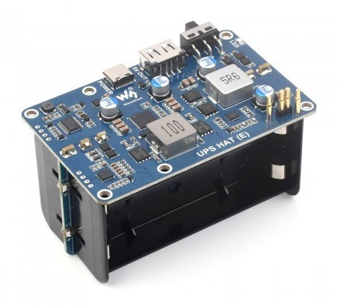
Note. Waveshare (n.d.-b). Image from Waveshare.
The Waveshare UPS HAT (E) is a four-cell 21700 lithium-ion uninterruptible power supply (UPS) board. It is mounted under the Raspberry Pi, not on top of it (via high-current pogo pins which are pressed against the underside of the Raspberry Pi) and it provides 5V at up to 6A. It passes mains power through whilst charging, takes over in case of mains power failure and communicates its state via I2C, including the individual cell voltages, the four individual currents, the power and the charger input. It also offers a USB-A output.
Just one thing about the pogo-pin connection should be named, as the 40-pin header of the Pi is left completely free (Waveshare, n.d.-b). The particular supply board used took the place of the pins needed by the buzzer, which means that the buzzer was not a pass-through or ribbon extension.
With Garbage-Guard, it's what makes an unattended deployment safe. The power module communicates via I2C and when the battery is low, starts a 5-minute countdown towards a clean shutdown, to the minimum of 5 per cent charge, with the option of grace period after boot; therefore, the Pi will never be cut off mid-write.

5 V to 12 V USB-A to DC Barrel Step-up Cable
Figure 32
5 V to 12 V USB-A to DC Barrel Step-up Cable
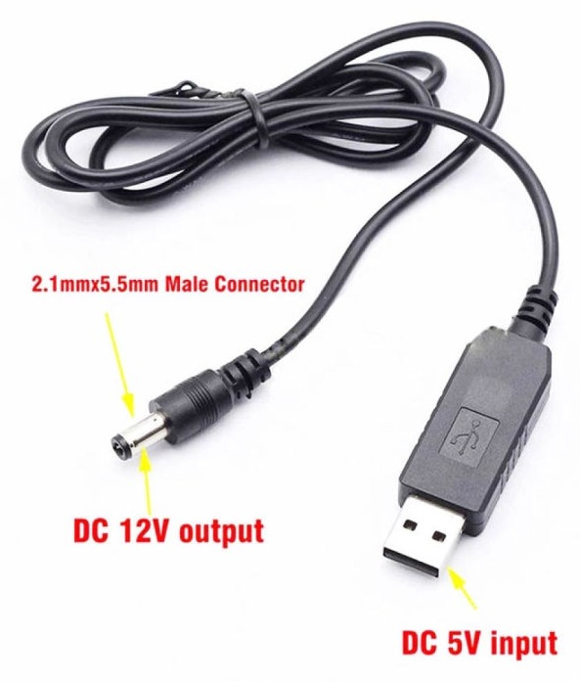
Note. Image from Shopee (n.d.).
A step up (or boost) converter is used to increase the voltage from a low to high level. This is the cable version of the above circuit with a plug at one end (USB-A) and a 5.5 mm barrel plug at the other end. It is rated 12V at 1A.
It does not require a separate power supply, but is powered from the USB-A output of the UPS HAT, which is battery-backed. An AC mains failure thus does not cause blindness of the system: the camera and the Pi go up or down together. The rating is also acceptable for the load as the camera draws no more than 0.42 A at 12 V, which is less than half of the cable rating at max rating of 12V and 0.8A.
That margin matters because a converter run near its limit is a common cause of intermittent faults in field equipment, and an intermittent camera would present as a detection problem rather than a power one.

USB-to-Ethernet Adapter and Wi-Fi Repeater
Figure 33
USB-to-Ethernet Adapter
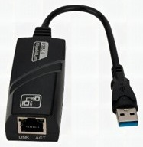
Note. Image from Shopee (n.d.).
Figure 34
Wi-Fi Repeater
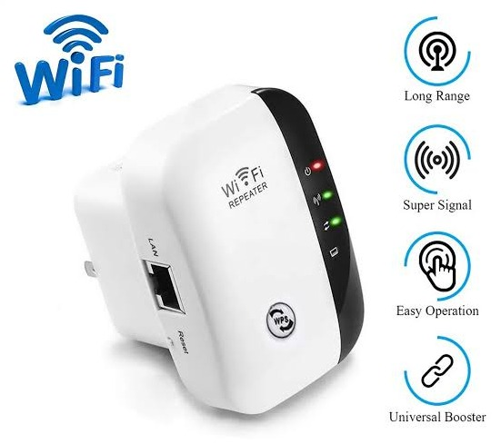
Note. Image from Shopee (n.d.).
The Raspberry Pi 5’s own Ethernet port is given over to the camera, on a direct link with fixed addresses at both ends, so the unit reaches the internet through a second, USB-to-Ethernet adapter plugged into one of the Pi’s USB ports. That adapter is cabled to the LAN port of a 2.4 GHz Wi-Fi repeater set to repeater mode, which joins the site’s wireless network and passes the connection through to the Pi.
The repeater was adopted after testing showed that the Pi’s built-in wireless adapter could not complete a connection to any network, an open one included. Routing through it has a practical benefit beyond that: to move the unit to another site, only the repeater is pointed at the new network, or at a phone hotspot, from its own setup page, and nothing on the Pi changes. Camera link and internet link remain on separate ports and do not interfere with each other if there is a fault.

7-inch IPS Touchscreen
Figure 35
7-inch IPS HDMI Touchscreen
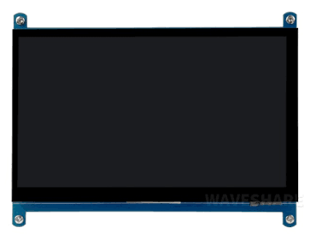
Note. Image from Shopee (n.d.).
The display is a 7-inch IPS panel at 1024 x 600. It takes video on HDMI and reports touch over USB-A. The panel type is worth mentioning because the screen is often viewed at an angle, in addition to at a straight-on angle when it's mounted, the IPS panel retains its color and contrast off-axis that a cheaper panel would not.
It's the only local interface provided by the operator. The dashboard runs full screen on it and the region of interest is tapped directly on the video. The system has a setting for the HDMI output to be disabled after a time limit and be disabled earlier if on battery and the touch is directly controlled so that a tap wakes the screen when the output is off.

Raspberry Pi Active Cooler
Figure 36
Raspberry Pi Active Cooler Fitted to a Raspberry Pi 5
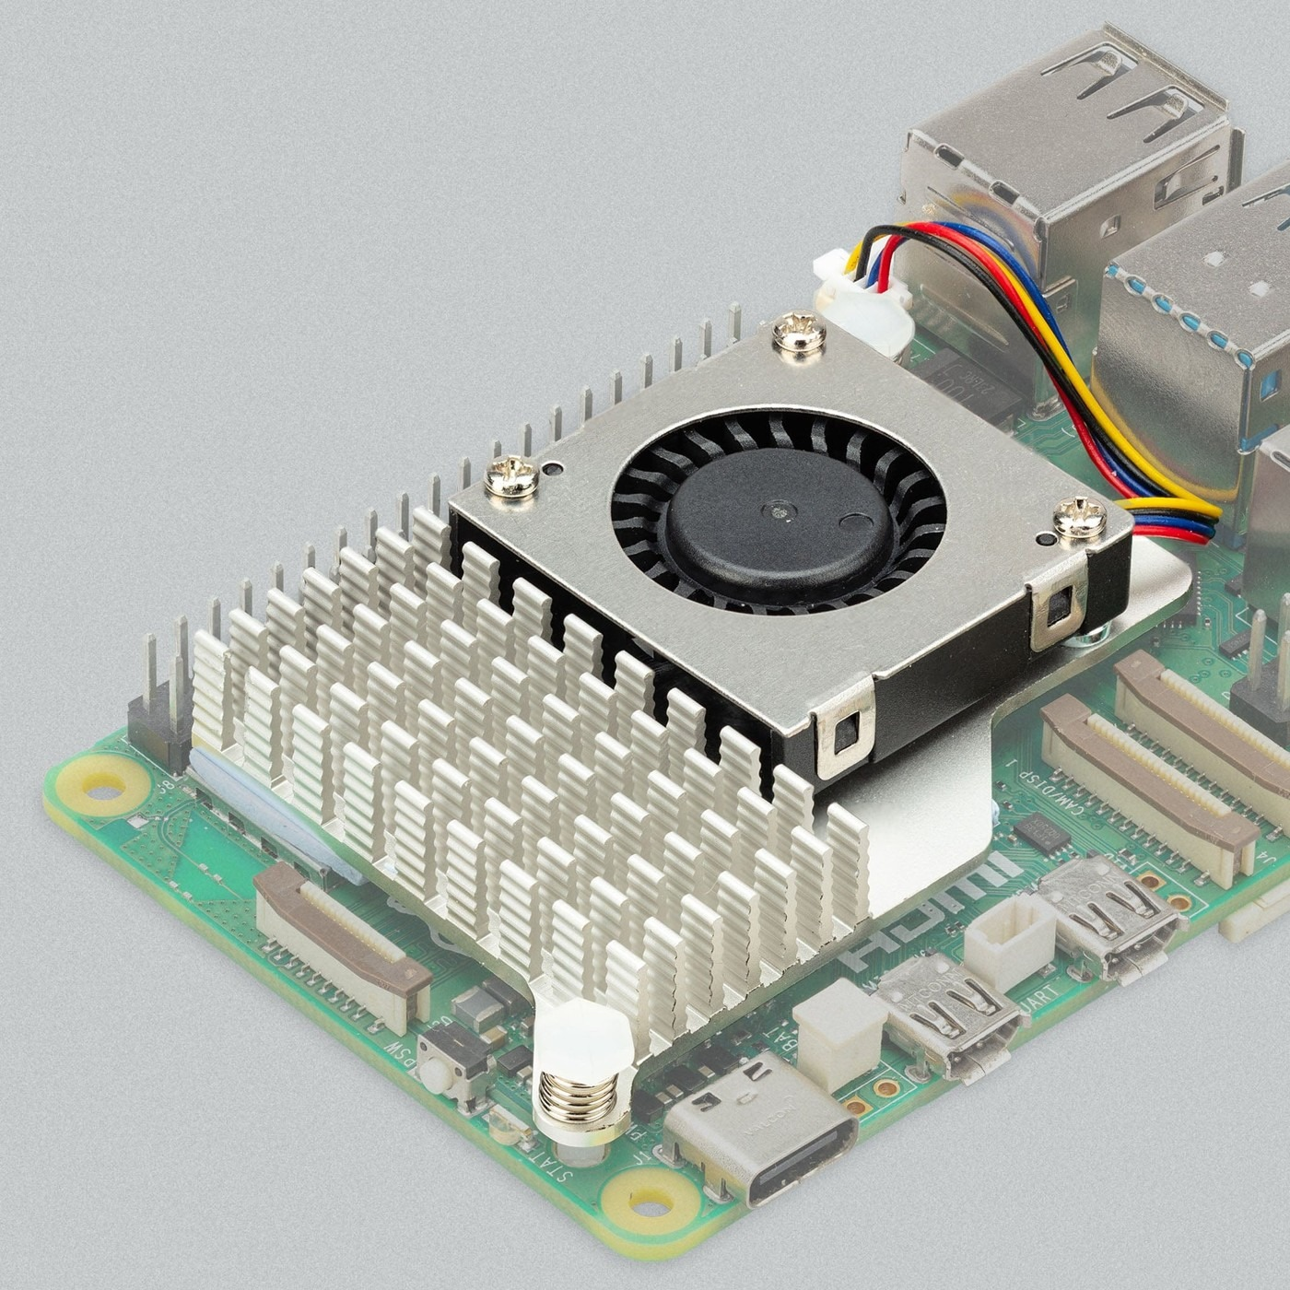
Note. Image from The Pi Hut (n.d.-a).
The Raspberry Pi Active Cooler is a heatsink and fan combination that attaches to the Pi 5's mounting points and operates from the board's dedicated fan header that allows the firmware to adjust the fan speed based on the CPU's temperature.
It's fitted because of sustained inference. Running detection on each frame keeps the processor at the edge of its thermal limits for an extended period of time, and if a Pi 5 hits its thermal limit, it slows down, which would manifest as latency increasing and/or frame rate dropping, but not as an obvious fault. Active cooling maintains the measured latency indicative of the hardware and not the thermal state of the hardware.

SanDisk 64 GB High Endurance microSD Card
Figure 37
SanDisk High Endurance 64 GB microSD Card
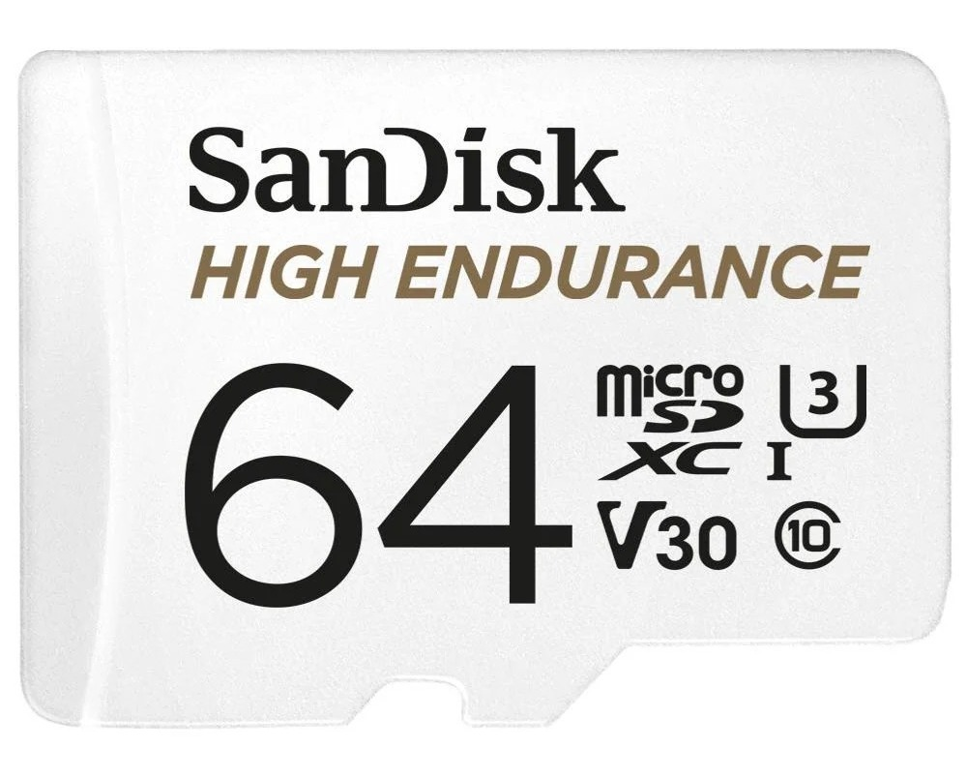
Note. The above image is courtesy of JB Hi-Fi (n.d.).
This card comes from SanDisk and is a "High Endurance" type. The line is not designed for the occasional large transfer a standard card is rated for, but for devices that will write continuously, for example a dashboard camera or a surveillance recorder.
The card will have Raspberry Pi OS only; the detection data will be stored on the solid-state drive detailed below. It's workload if for the operating system, primarily journal writes, logs and housekeeping of machine which is never powered off. That's a less demanding workload, but still continuous, and it's run for the duration of a whole field deployment, so it makes sense to have an endurance-rated card in a system that's left running unattended.

KingSpec 256 GB M.2 Solid-State Drive with Waveshare PCIe Adapter
Figure 38
KingSpec M.2 2242 NVMe Solid-State Drive
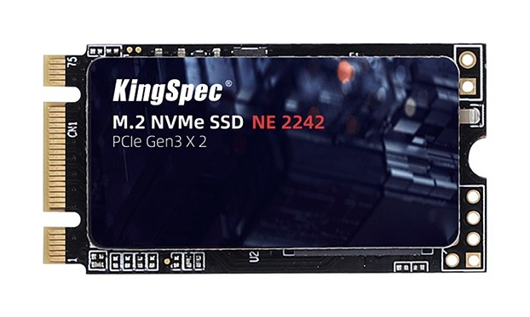
Note. Image from KingSpec (n.d.).
Figure 39
Waveshare PCIe to 2-Channel M.2 Adapter
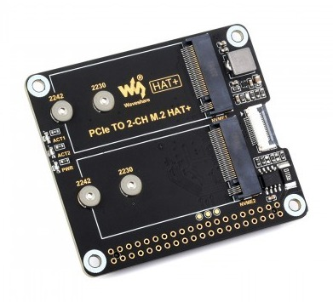
Note. Image from Waveshare (n.d.-a).
The solid-state drive is a KingSpec 256 GB module in 2242 form factor which is mounted on a Waveshare PCIe to two-channel M.2 adapter which plugs into Raspberry Pi 5's PCIe interface. It is a two-channel adaptor and requires a second module, to be used in conjunction with the first, and allows storage extension for a longer deployment without changing the board or the mounting.
The drive has the project folder, including the exported model, the database and the snapshot store while the operating system remains on the microSD card. It is separation that is the arrangement. Garbage-Guard writes a snapshot for each event recorded, and successively adds to the database, representing a constant flow of small writes to flash – the worst-case scenario for flash wear. Placing it on the drive ensures that all the intensive writing takes place on the drive best suited to absorb it and that if it fails there, it does not take the operating system with it.

Passive Buzzer Module
Figure 40
MH-FMD Passive Buzzer Module
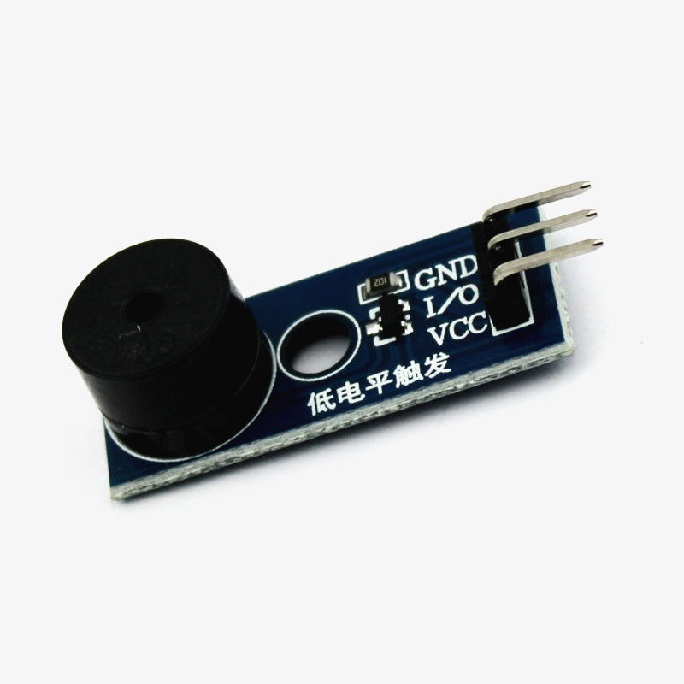
Note. Image from Shopee (n.d.).
A passive buzzer is a buzzer that produces no tone when the controller doesn't apply a varying signal to it. That's a drawback on paper but a boon in practice, as the pitch is then under software control and one device may be used to generate multiple sounds that can be distinguished from each other.
It is wired with the supply to physical pin 17 (3.3V), with the signal line to physical pin 32 (GPIO12), and with the ground to physical pin 34. Each event has its own sound with the buzzer module, and when the accumulation threshold is exceeded, a repeated alarm is raised.
It drives the pin by software pulse-width modulation (PWM) by default and switches to hardware modulation when the pin has been configured for it, which is louder and steadier. Quiet hours and a mute panel on the dashboard suppress it when configured by the operator.

Metal Waterproof Junction Box, Extension Lead and Case Fans
Figure 41
Closed Prototype Enclosure with the Touchscreen and Side Case Fan
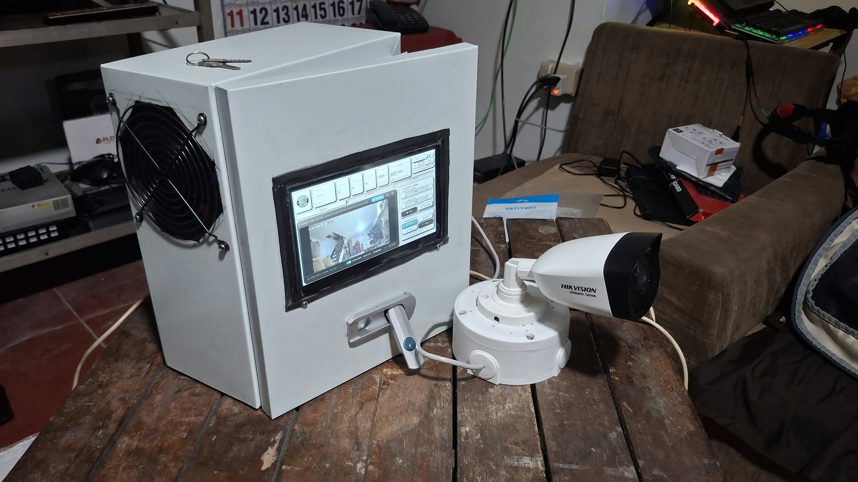
Figure 42
Side of the Prototype Showing the Case Fan, Cable Entry Holes and Camera
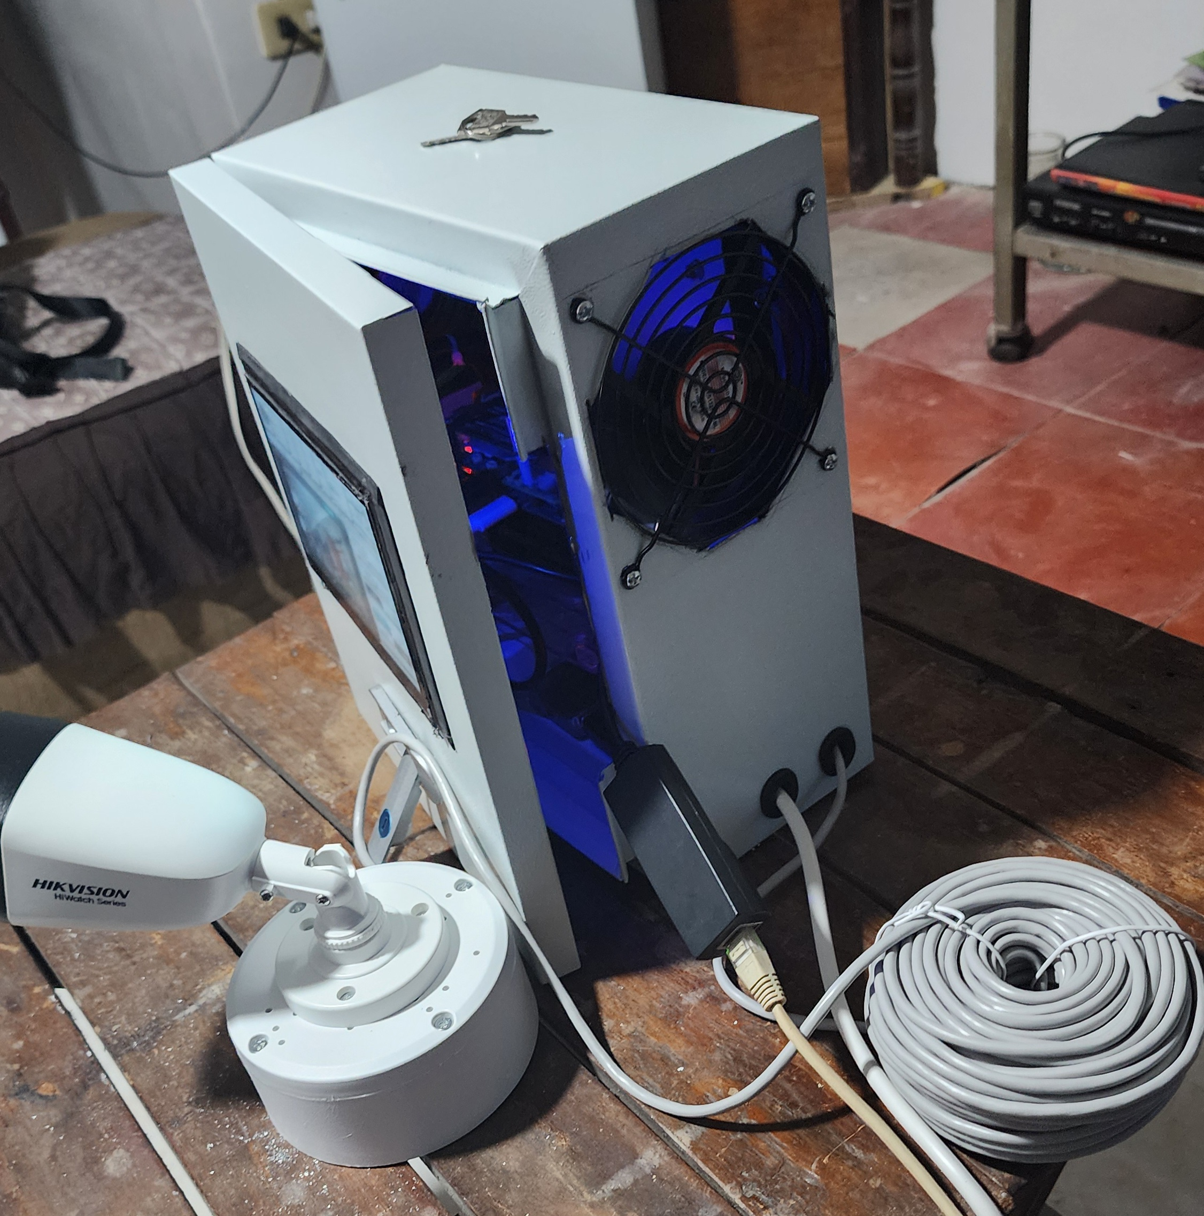
Figure 43
Opened Enclosure with the Raspberry Pi, UPS HAT and Wiring
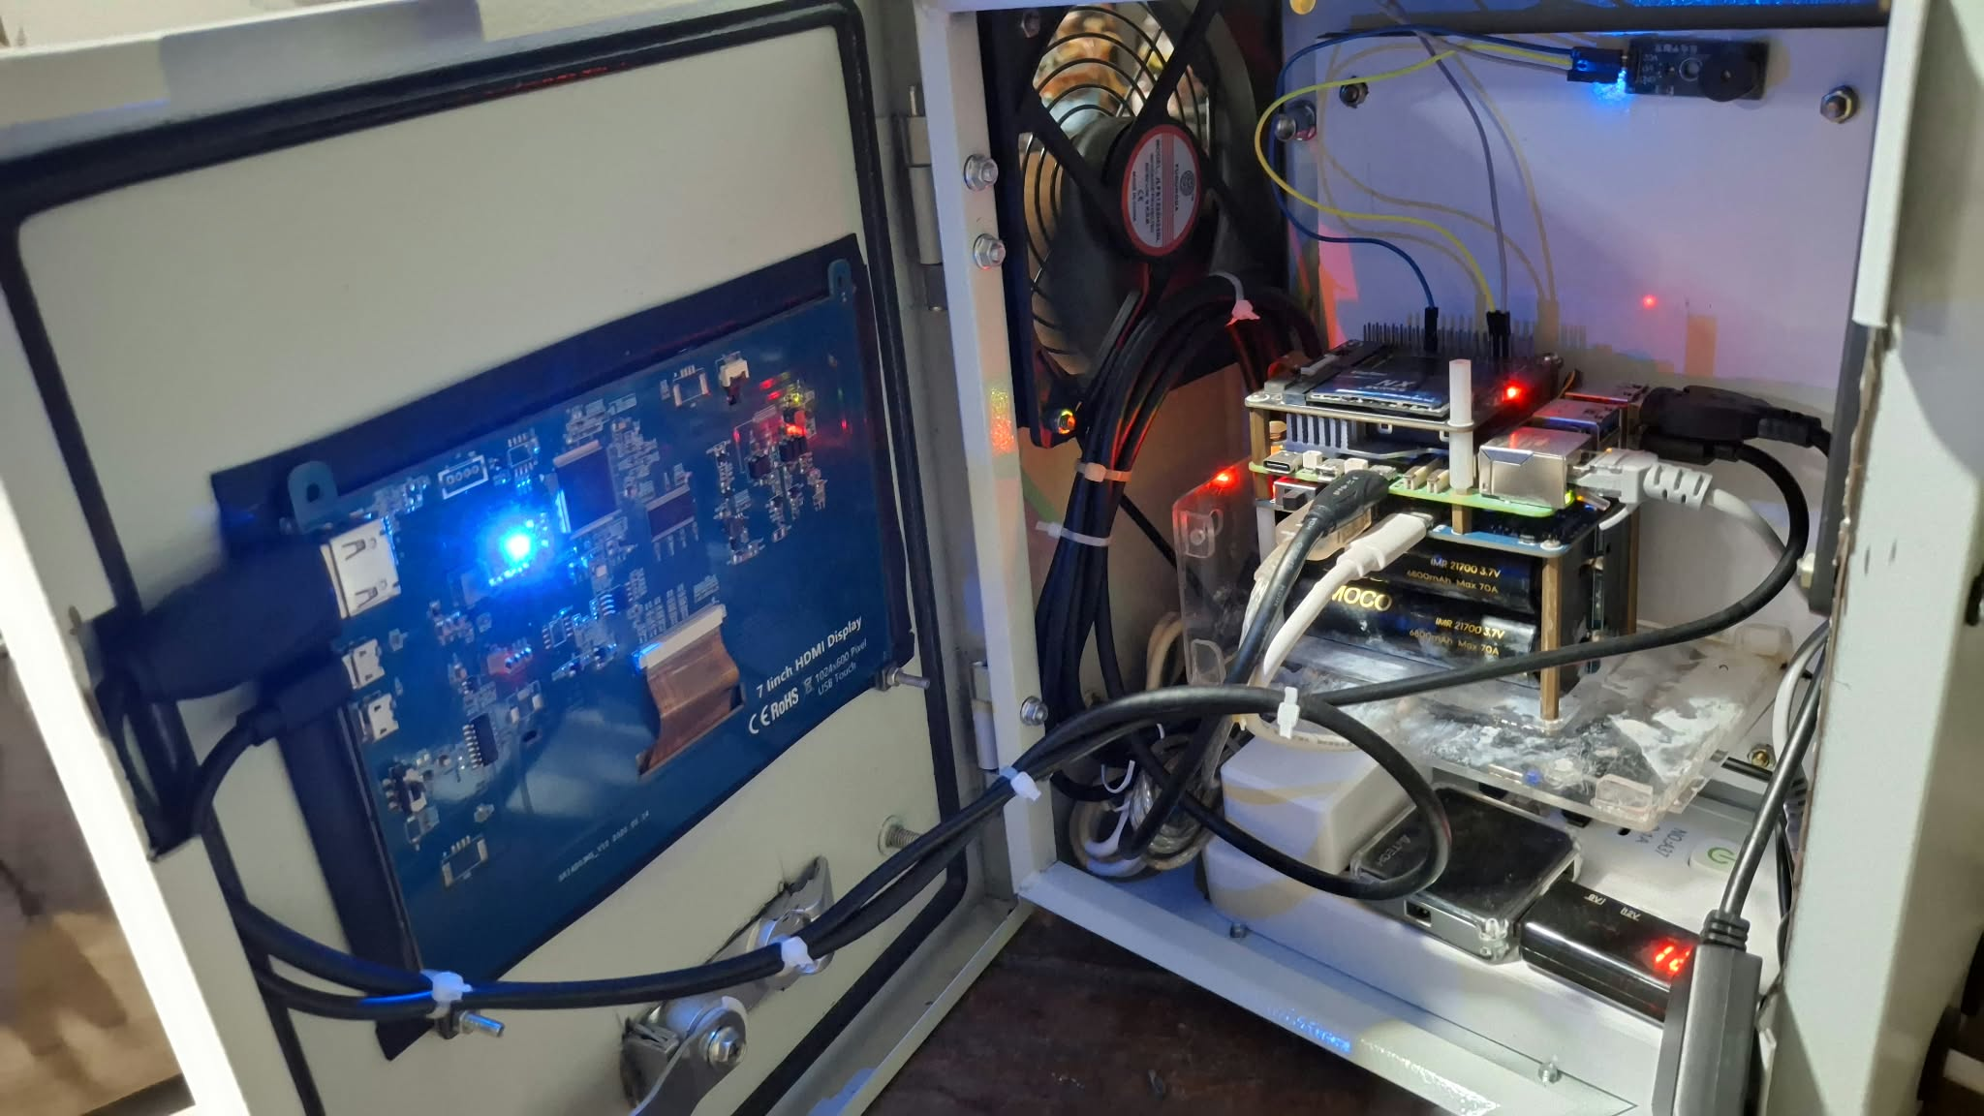
The electronics are housed in a metal waterproof junction box of the type sold for closed-circuit television installations, measuring 25cm x 30cm x 15cm, with openings cut for the AC mains extension lead and the camera cabling and sealed with a rubberized water sealant. There are two USB fans on both sides. The boards are stacked in a specific order: UPS HAT, Raspberry Pi (above the UPS HAT and running its active cooler), and PCIe with the SSD on top.
The distribution point inside the enclosure is the extension lead which conducts the AC Mains to the unit. The UPS charger and the two case fans are plugged into it. This split is significant and should be indicated and not glossed: UPS, cooler and camera continue to operate during an AC mains failure, case fans do not, they are plugged directly into the lead. When using battery, the enclosure fans are not working and the processor continues to run detection in a closed box. This is on purpose as running the fans from the battery would reduce the time the system can be able to detect.
The enclosure is not exposed to the weather. It is installed under cover and only the camera is installed outside, with wires going back to the box. The only part outside is the camera, which is the only element that is exposed to rain and sun, has an IP67 rating, while the other components of the enclosure have no such rating; and, by design, they are not exposed to the weather.

Software Components

Raspberry Pi OS and the Python Environment

The unit runs Raspberry Pi OS with the detection program in a virtual environment kept separate from the system packages. An installer registers the launcher so that switching the Pi on is enough to bring the system up: it checks the camera, raises the network profile if needed, activates the environment, opens the dashboard full screen and starts detection. If no network is in range, it shows a wireless setup screen first.

YOLO26n Detection Model

The detector is a YOLO26n convolutional neural network, trained on the custom dataset and exported to NCNN, an inference framework built for mobile and embedded processors. NCNN is used rather than the original weights because it is markedly faster on the Pi's Arm processor.
The model classifies three categories, in order: bottle, bag and food container. Its scores on the frozen test partition are a precision of 0.852, a recall of 0.685 and a mAP@0.5 of 0.745, and on the creek-only subset a precision of 0.742, a recall of 0.534 and a mAP@0.5 of 0.593. This is the figure that chapter IV runs against.

ByteTrack Multi-Object Tracker
ByteTrack is used to track objects from one frame to another, even if they are not detected at every time step, thus giving each object a consistent label throughout its entire appearance in the scene.
This maintains readability of the live view and helps maintain count. If that wasn't the case each item's box would be drawn again in each frame and may fade in and out between classes or for a whole frame. The boxes on the dashboard have a small number, starting at 1, and the number is released after the object has been missing for approximately thirty frames.

Region of Interest and Accumulation Counter

The Region of Interest (ROI) is a polygon drawn on the video by the operator and saved on disk and reloaded at start up. When the position of the detection falls outside it is discarded prior to tallying, and that is why the bank and the bridge wall don't count.
At the end of each frame the counter will be updated with the number of items inside that region, smoothed as the median of the last 15 frames, thus a single missed or false detection does not cause the counter to move. When the smoothed count reaches the threshold (20, by default and can be set from the Settings tab) an alert is raised once only, and will re-arm once the count has dropped to 15; this means that a pile of items oscillating around the threshold does not trigger repeated alerts. Thus, the twenty items shown in the display means that there are approximately twenty items in the bag; the threshold is not assumed, but calibrated on the spot.

SQLite Database

Accumulation alerts, brief alerts that reached the threshold but weren't sustained, mutes, manual captures and test alerts are stored in a local SQLite database, with each alert and capture having a snapshot of the boxes, monitored area and count stamped onto the image. Every 100 frames, a summary of the processing latency is written. No alert is raised for frames that do not trigger an alert, but they are displayed on the dashboard and not stored in the database, ensuring a small database over a long deployment.
This has the benefit that the system is not losing anything when the network goes down, and that the snapshot they saved can be used to later verify any reading made by the system.

HTML5, CSS, JS

The dashboard is a one .HTML file of code and inside it is HTML5 (Hypertext Markup Language 5, JS (JavaScript), and Cascading Style Sheets (CSS) served over HTTP from the Pi by Python's built-in web server, with no build step and no external dependencies. It has three tabs: Monitor, History and Settings.
Monitor displays the live feed with the bounding boxes, running count, frame rate and mute panel and is where the region of interest is drawn. History displays snapshots of events that have been recorded and a filter bar. Settings contains the detection threshold, the alert preferences, the screen saver and the power options.

Firebase

A set of access rules is used to communicate events and system state from the unit to the phone using Firebase.
It is in place so an operator doesn't have to be at the creek to know that the threshold has been exceeded. The Pi is the system of record and the cloud has a copy.

Android Studio

The Android app built in Android Studio is coded using Kotlin, .XML, and Jetpack Compose. It is push-alert capable, is able to display detection history and can adjust detection settings remotely.
It is the second half of the alerting path. The buzzer and the on-screen warning serve whoever is present; the application serves whoever is not.

3.5 Project Development
Figure 44
V-Model SDLC Model
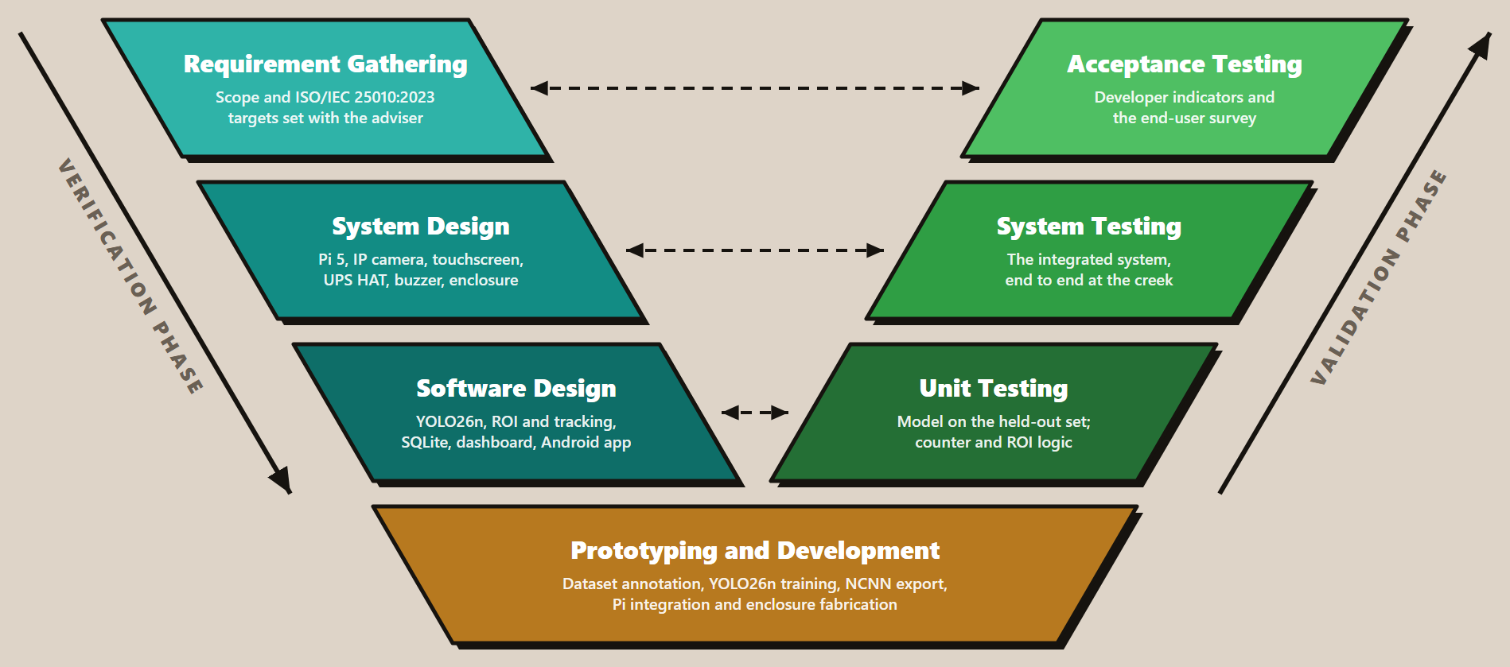
Note. Adapted from “What is the V-model in software development?” by Oppermann & Whitfield, 2025
The researchers adapted the traditional V-Model Software Development Life Cycle for the Garbage-Guard System to better suit the hardware and software integration requirements for the prototype. Figure 44 shows the relationship for each phase, ensuring that they are systemically combined throughout the development process. This adapted V-Model has three phases which are Verification, Prototyping & Development, and Validation. This approach ensures a smooth and strict relationship between the design parameters and testing protocols so each design and test phase can be conducted in parallel to each other.
Figure 45 shows how the detection model itself was produced, which the V-Model places inside the prototyping and development phase. The sequence runs from collection at the creek through annotation, the dataset split, training, evaluation on the held-out partition, export to NCNN and deployment on the Raspberry Pi. The dashed return path is not decorative: weak per-class results sent the work back for further collection and annotation, and the model deployed at the creek, v7, came out of the eighth training run rather than the first.
Figure 45
Model Training and Deployment Pipeline
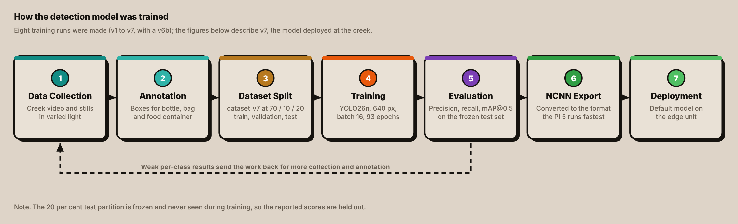

Phase 1: Verification (Left Side of the V)
This phase defines the exact parameters the system must meet, and also the design of hardware and software to achieve those goals.

Requirement Gathering
The researchers consulted with researchers’ thesis advisor Prof. Jonel R. Macalisang, to make the scope and title of the Garbage-Guard project. During the phase, the requirements were specifically defined. Under the guidance of researchers’ Technical Research Advisor, Prof. Ma. Ian De Los Trinos, the criteria for the acceptance testing were accepted using the ISO/IEC 25010:2023 standard. The assessment covered three software quality characteristics:
- Functional Suitability: To evaluate the accuracy of the garbage detection and of the accumulation count.
- Performance Efficiency: Assess speed and time of detection.
- Usability: Test the dashboard and alerts for readability and usability by those who will use them.

System Design
In this stage, the researchers planned the physical system architecture and the required components to show portability, and continuous operation. The researchers designed the layout of the hardware, utilizing these components:
- Camera (Hikvision HiWatch HWI-B140H) - The sensor for real-time computer vision capture.
- Raspberry Pi 5 (8 GB) with the official Active Cooler - The core processor that executes the computer vision algorithm.
- 7-inch IPS touchscreen - The display interface that shows the real-time video feed and the log history of detected garbage, and is used to draw the monitored area.
- Storage - A 64 GB High Endurance microSD card holds the operating system, and a 256 GB M.2 solid-state drive on a Waveshare PCIe adapter holds the model, the database and the snapshots.
- Waveshare UPS HAT (E) with four 21700 cells - Provides an uninterruptible power supply with a safe shutdown on power loss; its USB-A output also feeds the camera through a 5 V to 12 V step-up cable.
- Extension lead, UPS charger and two USB case fans - AC Mains power reaches the UPS charger and the case fans through the lead; the fans stop when AC mains are lost.
- USB-to-Ethernet adapter and Wi-Fi repeater - Carries the "cloud link" to the site's wireless network.
- Passive buzzer module - Gives an audible accumulation alert from a GPIO pin.
- Metal waterproof junction box - Protects the electronics from the elements, openings sealed with water sealant, just the camera is exposed to the elements.

Software Design
The software design was developed in three differing layers:
- AI / Computer Vision: Real-time detection and counting using a YOLO26n class convolutional neural network exported to NCNN, region of interest filter and ByteTrack tracking.
- Front-End (UI/UX): The touch screen dashboard on the unit, an Android application for remote alerts, history and settings.
- Back-End (Database): Simple local SQLite database to keep track of detections, counts and snapshots which sync with Firebase.
Modularity and separation of concerns between detection, processing and visualization components are provided by the architecture.

Phase 2: Prototyping and Development (Vertex of the V)
Represents the transition point between the theoretical design and the actual making of the project in the adapted V-Model. The development process started with creating and labeling a custom dataset, training YOLO26n model iteratively on the workstation GPU, and exporting the trained model to NCNN. Next, the model was tested on Raspberry Pi 5 to ensure its compatibility and functionality. The tracker, the region filter, the counter, the dashboard and the Android application were developed around the model.
The prototype was made portable. The Raspberry Pi, UPS, storage and the step-up cable are all inside a metal waterproof junction box with holes cut in the sides for the cables and sealed with water sealant, and two USB case fans mounted to the side. The unit is located under shelter and only the camera is wired to the unit and placed outside the unit on a roof above the water.

Testing Parameters and Scale of Measurement
Table 3
ISO/IEC 25010:2023-based Metrics Descriptions and Scale of Measurements for Garbage-Guard
Objectives |  | Definitions | Metrics | Description | Scale
1. | Functional Suitability  (Classification) | The ability of the YOLO26n model to correctly identify and classify solid garbage (bottles, bags, food containers). | Percentage average (%) of correct garbage recognition against total samples tested. | Excellent | 95% - 100%
 |  |  |  | Very Good | 90% - 94.99%
 |  |  |  | Good | 80% - 89.99%
 |  |  |  | Fair | 70% - 79.99%
 |  |  |  | Poor | Below 70%
2. | Functional Suitability  (Accumulation Detection) | The system’s ability to accurately track the item count and successfully trigger an “Accumulation Alert” once the threshold (default 20 items) is reached. | Percentage average (%) of successful alert triggers out of total simulated accumulation test cases. | Excellent | 95% - 100%
 |  |  |  | Very Good | 90% - 94.99%
 |  |  |  | Good | 80% - 89.99%
 |  |  |  | Fair | 70% - 79.99%
 |  |  |  | Poor | Below 70%
3. | Performance Efficiency | The inference time and processing latency of Raspberry Pi 5 to draw bounding boxes on the live camera feed on each floating garbage. | Average inference time (in seconds) during real-time monitoring. | Excellent | Below 0.5s
 |  |  |  | Very Good | 0.51s - 1.5s
 |  |  |  | Good | 1.51s - 3.0s
 |  |  |  | Fair | 3.1s - 5.0s
 |  |  |  | Poor | Above 5.0s
Table 3 shows and defines the metrics that will be used to grade each objective of the Garbage-Guard system based on the ISO/IEC 25010:2023 software quality standards.
(1) The first objective focuses on Functional Suitability (Classification), specifically the accurate measurement of identifying and classifying floating solid garbage such as garbage bottles, garbage bags, and or food containers using the YOLO26n computer vision model. The computations used to determine the accuracy of the garbage classification utilizing variables from the confusion matrix, where the variables are True Positive (TP), True Negative (TN), False Negative (FN), and False Positive (FP) the formulas are listed below:
Precision$= \frac{TP}{TP+FP}$ , Recall$= \frac{TP}{TP+FN}$ , Accuracy$= \frac{TP + TN}{Total Objects} × 100$

(2) The second objective defines an additional layer of Functional Suitability regarding the system’s Accumulation Detection capability. The system counts the number of items found and when a threshold is reached (default set for 20 garbage items detected), the system generates an “Accumulation Alert” to mathematically and systematically alert the public to the creek's level of pollution. The percent number of successful alert triggers divided by the total simulated accumulation test cases is used to measure the parameter as the equation below:
Success Rate$= \frac{Number of Successful Alerts }{Total Number of Trials }$ $× 100$
(3) Lastly, the third objective, Performance Efficiency measures the real-time responsiveness of Raspberry Pi 5. This metric evaluates the inference time and processing latency of the Raspberry Pi 5 to successfully process a live camera feed request and draw bounding boxes on each floating garbage without severe hardware degradation. The system automatically records the latency time for each frame, defined as the difference between the frame capture time (Start Time) and the frame detection completion time (End Time), so as to provide an objective evaluation. The last parameter is measured by applying the averaging method to determine the mean inference time (in seconds) over a fixed test time, as follows:
Average Latency$= \frac{∑ ( T_{End} -T_{Start} )}{Total Frames}$

Phase 3: Validation (Right Side of the V)
This phase goes up the V-Model, directly testing the design developed during the first phase, ensuring all the mathematical and functional conditions are fulfilled.

Unit Testing
The initial testing on the right side of the V-Model is the unit testing phase. It tests the software and hardware aspects of the system in a controlled environment. Depending on the scope and goal of the project, this will include isolating the YOLO26 algorithm, the accumulation counter logic, and latency logging mechanism on the Raspberry Pi 5 to make sure they work correctly before the full integration.

1. Classification Evaluation
To verify its software components, particularly the object detection algorithm, the frozen held-out test partition is used. The model is mathematically validated using a Confusion Matrix that consists of True Positives (TP), False Positives (FP), True Negatives (TN), False Negatives (FN). Evaluation of the AI Model’s performance is computed based on the following core statistical formulas:
- Precision: Measures the model’s ability to avoid False Positives. It basically measures how many of the items the YOLO26 model identified as garbage were actually garbage.
Precision$= \frac{TP}{TP+FP}$
- Recall: Measures the model’s ability to detect all the actual garbage that is present. It recalls how many of the actual garbage items present in the water were successfully captured by the YOLO26 model. In short, the model’s ability to avoid False Negatives
Recall$= \frac{TP}{TP+FN}$
- Accuracy: The overall correctness of predictions, the ratio of correct predictions to the total number of cases examined. For object detection it is reported for completeness, and mean average precision at an overlap threshold of 0.5 (mAP@0.5) is reported alongside precision and recall, since it is the standard detection measure. The model must reach a precision of at least 80%.
Accuracy$= \frac{TP + TN}{Total Objects} × 100$

2. Accumulation Detection Evaluation (Counter Logic)
To mathematically determine if the system correctly tracks item counts and triggers the “Accumulation Alert” at the 20-item threshold, simulated accumulation test cases are conducted.
Success Rate: Measures the percentage of successful alert triggers out of the total number of simulated trials.
Success Rate$= \frac{Number of Successful Alerts }{Total Number of Trials }$ $× 100$

3. Performance Efficiency Evaluation
Measures real-time responsiveness of the Raspberry Pi 5, the system automatically checks the latency of each frame.
Average Latency: Evaluates the mean inference time (in seconds) across a test duration to ensure that there is no severe hardware degradation. It is the difference between the time of the frame captured (Start Time) and the time the detection was completed (End time).

Average Latency$= \frac{∑ ( T_{End} -T_{Start} )}{Total Frames}$
Table 4
Unit Testing Cases for Controlled Environment Evaluation
Test Case ID | Objective | Procedure | Expected Result | Actual Result | Successful Trials / 10
TC_UNIT_01 | Evaluate Classification Precision, Recall and mAP@0.5 | Process the trained model on the frozen 20% of the annotated data (held-out test partition) and store the per class and overall results | The reported precision is at least 0.80 with recall and mAP@0.5 indicated for each of the three classes.
TC_UNIT_02 | Validated Accumulation Counter Logic | Programmatically simulate the continuous detection of floating garbage items, incrementing up to the default threshold | The system triggers the automated “Accumulation Alert” once when the smoothed count reaches the 20-item threshold, and does not raise it again until the count has fallen to the re-arm level of 15.
TC_UNIT_03 | Verify the Performance Efficiency Logging | Run sample video frames through Raspberry Pi 5 to execute the latency tracking script. | The system is able to calculate the latency without hardware crashing, which is the difference between the start time and end time.

System Testing
After verification of the units, the System Testing is performed. This stage includes a test of the entire system, which comprises the Raspberry Pi 5, camera, YOLO26n model, region filter, tracker, database, touchscreen dashboard, the Android application and the alerting logic. Prototype is installed at local creek or barangay site for environmental monitoring. In addition to the model itself, it validates that the system is capable of receiving real-time video streams, that it has the ability to only alert for floating surface items that are visible in the video (excluding items that are sunk or heavily obscured by other items), it counts what items are in the monitored area, it stores every alert, it notifies the user about an alert, and it maintains efficient processing under continuous load.
Table 5
System Testing Cases for Real-World Environmental Conditions
Test Case ID | Objective | Procedure | Expected Result | Actual Result | Successful Trials / 10
TC_SYS_01 | Real-World Object Detection. | Deploy the setup beside the waterways/creek and stream the live footage onto the Raspberry Pi 5 for real-time analysis | Bounding boxes are accurately drawn over visible floating bottles, bags, and food containers, ignoring sunken garbage or organic debris
TC_SYS_02 | Real-time Accumulation Alert | Allow the system to continuously monitor the creek until 20 valid targeted garbage items accumulate on the water surface. | Successfully recognizes the threshold breach and triggers the automated accumulation alert in a live setting.
TC_SYS_03 | Real-time Processing Latency | Monitor the edge computing hardware’s responsiveness while processing the live video feed for a standardized test duration. | The average inference latency per frame is logged automatically and remains stable without causing the system to crash or overheat.
TC_SYS_04 | System Flow (End to End) | Walk the flowchart in one run: switch the unit on, confirm the camera feed appears, place test items in the monitored water area, watch the count rise, cross the threshold, and observe the alert and the saved record. | Each step of Figure 28 happens in order: camera on, detection and tracking, counting inside the region, threshold alert, alert record saved, and the result shown on the dashboard and the application.
TC_SYS_05 | Live Dashboard | Open the dashboard on the touchscreen while detection runs. | The live feed with bounding boxes, class labels, the running count and the frame rate is shown and updates continuously.
TC_SYS_06 | Region of Interest | Draw the monitored area on the water, then place the same test item inside it and outside it. | The item inside the area is counted and the item outside it is ignored.
TC_SYS_07 | Stable Tracking and Count | Let one item drift into the monitored area and out of it again. | The item keeps a single identity number while in view, adds one to the count while it is inside the area, and drops off the count after it leaves.
TC_SYS_08 | Event Storage | Raise an accumulation alert, then take a manual capture, then open the History tab. | Both records appear with their time, counts and a saved snapshot, read back from the database.
TC_SYS_09 | Alert Delivery | Raise an accumulation alert while the Android application is connected. | The alert is displayed on the dashboard, the buzzer is activated, and a push notification goes to the application.
TC_SYS_10 | Threshold Setting | Change the accumulation threshold in the Settings tab, then repeat the count. | The new threshold takes effect and the alert is raised at the new value.

Acceptance Testing
The testing phase is equivalent to the requirement gathering phase of the adapted V-Model. This phase is representation of the working prototype with a live demonstration in the field to make sure it meets the original aims of the study.
The prototype will be operated at the creek for a week and at least 4-5 days. The researchers maintain an uptime log of the number of days and hours the system ran without a crash or overheating, and the threshold calibration that took place on site. This log is the evidence for the Performance Efficiency indicators and the end users respond to the usability survey after using the system during this deployment.
In order to get an accurate assessment and define the clear testing limits this phase will be separated into two different testing perspectives: The developer Side (Internal Acceptance) and the end-user side (External Acceptance).

Developer Side Acceptance Testing
The developer side boundary is to only evaluate the technical performance, stability of the hardware and accuracy of the algorithmic system of the Garbage-Guard system. Evaluation is done only by the researchers and based on the ISO/IEC 25010:2023 quality standards identified in the scope of the study. The researchers will monitor during the live demo to see if the prototype achieves the desired percentage averages and latency.
Table 6
Acceptance Testing Evaluation Test Cases
Test Case ID | Objective | Procedure | Expected Result | Actual Result | Successful Trials / 10
TC_ACC_01 | Functional Suitability (Classification) | Conduct a live field demonstration to evaluate the percentage average of correct garbage recognition against total samples. | The system achieves a target of “Good” (80%) or better in successfully classifying the 3 target garbage types.
TC_ACC_02 | Functional Suitability (Accumulation Detection) | Conduct a live field demonstration to check the percentage average of successful alerts triggers. | System achieves a target of “Good” (80%) or better in successfully triggering alerts when reaching the 20-item threshold
TC_ACC_03 | Performance Efficiency (Latency and Stability) | Review internal logs generated during the live demonstration to assess edge computing latency | Raspberry Pi 5 maintains a target average inference time of “Good” (1.51s - 3.0s) or faster (Below 1.5s) Without crashing.
The demonstration will involve watching the system in the field and determining whether the prototype achieves the desired percentage averages and latency. This phase has structured test cases as shown in Table 6.
To make a formal quantification of the results of the live demonstration, the scientists will test the system with an internal evaluation checklist, depending on the requirements of the evaluation system.
Table 7
Developer-Side Internal Acceptance Indicators
ISO Characteristics | Indicator Code | Evaluation Statement
Functional Suitability  (Target: Algorithm Accuracy) | DEV-FS1 | The YOLO26n algorithm accurately checks the 3 target floating garbages (bottles, bags, food containers) while ignoring sunken debris and organic matter.
 | DEV-FS2 | In a live situation, the automated “Accumulation Alert” is activated when the 20 item threshold is reached with the system's counter logic ensuring it happens at the right time.
Performance Efficiency  (Target: Hardware & Speed) | DEV-PE1 | The video streaming is processed by Raspberry Pi 5 with minimum interference latency -< 3.0 Seconds per frame.
 | DEV-PE2 | Edge computing hardware maintains uninterrupted operation without crashing or overheating.

End User Side Acceptance Testing
This boundary moves the focus from the software and hardware to the system's external interface and its usability. Target stakeholders from the local barangays will interact with the system's touchscreen monitor during the live field demonstration and this evaluation will be made by them.
To quantify the user acceptance, a survey based on the ISO/IEC 25010:2023 characteristics of Usability will be administered to the stakeholders immediately after the demonstration.
Table 8
End User Side Acceptance Survey Indicators
ISO Characteristics | Indicator Code | Evaluation Statement
Usability  (Target: Interface and Operability) | USR-U1 | Information displayed on the monitor is easy to read and understand.
 | USR-U2 | Visual bounding boxes on the camera feed clearly showed where the garbage is located on the creek.
 | USR-U3 | Accumulation Alert is clear, noticeable and effectively informs when the creek needs cleaning
 | USR-U4 | The system provides helpful insights that would assist local authorities in monitoring creek pollution.
 | USR-U5 | The Android application shows the alerts and the history clearly, and what it shows matches the touchscreen.
Each statement in Table 8 is rated on the five-point Likert scale in Table 9. The responses to a statement are summarized as a weighted mean, the sum of each scale value multiplied by the number of respondents who chose it, divided by the total number of respondents, and the mean is read against the ranges below. The usability target is a weighted mean of at least 2.61 (Good) for every indicator, matching the Good target used for the other characteristics in Table 3.
Table 9
Five-Point Likert Scale and Interpretation of the Weighted Mean
Scale | Verbal Description | Weighted Mean Range | Interpretation
5 | Strongly Agree | 4.21 – 5.00 | Excellent
4 | Agree | 3.41 – 4.20 | Very Good
3 | Neutral | 2.61 – 3.40 | Good
2 | Disagree | 1.81 – 2.60 | Fair
1 | Strongly Disagree | 1.00 – 1.80 | Poor
Weighted Mean = Σ (f × w) / N, where f is the number of respondents who chose a scale value, w is that scale value, and N is the total number of respondents.

IV. RESULTS AND DISCUSSION

4.1 Project Description
[Describe the finished prototype: what it is, where it was installed, and what it does in operation.]

4.2 Project Structure
[Explain how the system was built. Cover the touchscreen dashboard and the Android application, the tools used for each, and screenshots of every screen mapped to the requirement it satisfies.]

4.3 Project Capabilities and Limitations
[State what the system does reliably and what it does not, including the per-class detection weakness and the behavior of the enclosure fans on battery.]

4.4 Test Case Results
[One subsection per specific objective, each with its completed table from Chapter III and a short discussion. Fill the Actual Result and Pass/Fail columns, reporting successful trials out of ten.]

4.5 System Flow Test Results
[The end-to-end run through the flowchart, with a screenshot at each step from camera start to alert on the dashboard and the application.]

4.6 Field Deployment Results
[Uptime over the creek deployment, measured latency against the Table 3 scale, and the threshold calibration record.]

4.7 Evaluation Results
[Developer-side indicators from Table 7 and the end-user survey results from Table 8, with mean scores and their interpretation.]

V. SUMMARY OF FINDINGS, CONCLUSIONS, AND RECOMMENDATIONS

5.1 Summary of Findings
[Summaries the result for each specific objective in turn, without interpretation.]

5.2 Conclusions
[State what the findings mean for the problem set out in Chapter I, and whether each objective was met.]

5.3 Recommendations
[Recommend further work. The current system suggests at least: a scalable multi-camera setup so one unit can cover several creek points; a wireless camera to remove the cable run; a longer detection range for mountings further from the water; more bag training data, since bags are the weakest class; and a battery-powered enclosure fan, since the case fans stop on mains failure.]

VI. REFERENCES
Acot, F. T., Sajorne, R. E., Omar, N.-A. K., Suson, P. D., Rallos, L. E. E., & Bacosa, H. P. (2022). Unraveling macroplastic pollution in rural and urban beaches in Sarangani Bay Protected Seascape, Mindanao, Philippines. Journal of Marine Science and Engineering, 10(10), 1532. https://doi.org/10.3390/jmse10101532
Al Noman, Z., Li, F. H., Almukhtar, F., Rahaman, B., Omarov, S. Ray, Shahajan Miah, C., Wang, C. (2022). A computer vision-based lane detection technique using gradient threshold and hue-lightness-saturation value for an autonomous vehicle. International Journal of Electrical and Computer Engineering (IJECE). https://ijece.iaescore.com/index.php/IJECE/article/view/27007
Arante, H. R. C., Sybingco, E., Roque, M. A., Ambata, L., Chua, A. Y., & Gutierrez, A. N. (2025). Development of a secured IoT‑based flood monitoring and forecasting system using genetic‑algorithm‑based neuro‑fuzzy network. Sensors, 25(13), 3885. https://doi.org/10.3390/s25133885
Balachandran, N., Talavera O. (2023). Apparatus and method for waste monitoring and analysis (US11788877B2). Google Patents. https://patents.google.com/patent/US11788877B2
Campbell, D. P., Gormley, M., Kelly, D., Xue, Y., & Stewart, C. (2022). Drainage monitoring apparatus and system (WO2022254204A1). Google Patents. https://patents.google.com/patent/WO2022254204A1/en
Chen, L., Li, G., Xie, W., Tan, J., Li, Y., Pu, J., Chen, L., Gan, D., & Shi, W. (2024). A survey of computer vision detection, visual SLAM algorithms, and their applications in energy-efficient autonomous systems. Energies, 17(20), 5177. https://doi.org/10.3390/en17205177
Chordiya, S. B., Das, S., Garg, R., Jain, V., Kumar, A., Nagpure, S. G., Nagvekar, Y. D., Parlikar, A. S., Regulwar, G. B., & Saini, D. K. (2020, September 9). AU2020102191A4 - WCM-Smart City: WASTE COLLECTION AND MANAGEMENT UNDER SMART CITY USING IOT - Google Patents. https://patents.google.com/patent/AU2020102191A4/en?q=(WCM-Smart+City:+WASTE+COLLECTION+AND+MANAGEMENT+UNDER+SMART+CITY+USING+IOT)&oq=WCM-Smart+City:+WASTE+COLLECTION+AND+MANAGEMENT+UNDER+SMART+CITY+USING+IOT
Corpuz, J. C. G. (2025). Wastewater management in the Philippines: A call for localized solutions and policy integration. Environmental Health Insights, 19. https://doi.org/10.1177/11786302241311529
Das, T., Das, N., Zuthi, M. F. R., Pal, S. K., Kraft E., Thomas H., & Kuehlewindt S. (2025). Plastic waste in marine ecosystems: Identification techniques and policy interventions. Water, Air, & Soil Pollution, 236, 478. https://www.researchgate.net/publication/391870234_Plastic_Waste_in_Marine_Ecosystems_Identification_Techniques_and_Policy_Interventions
Den Hartog, E. D., & Voncken, R. G. H. (2017). System for monitoring water drainage (WO2017089181A1). Google Patents. https://patents.google.com/patent/WO2017089181A1/en
Development Asia. (2024, February 28). Optimizing Municipal Waste Collection in the Philippines through a Smart App. Retrieved March 8, 2026, from https://development.asia/case-study/optimizing-municipal-waste-collection-philippines-through-smart-app
Ella, D. M., Lim, D. M., Lu, B., & Cabauatan, R. (2022). The impact of solid waste management to the economic growth in selected OECD countries and Philippines. Journal of Economics, Finance and Accounting Studies, 4(1). https://doi.org/10.32996/JEFAS.2022.4.1.20
Garcia, A., Saez, Y., Harris, I., Huang, X., & Collado, E. (2025). Advancements in air quality monitoring: a systematic review of IoT‑based air quality monitoring and AI technologies. Artificial Intelligence Review, 58(9), 275. https://doi.org/10.1007/s10462-025-11277-9
Gryech, I., Assad, C., Ghogho, M., & Kobbane, A. (2024). Applications of machine learning & Internet of Things for outdoor air pollution monitoring and prediction: A systematic literature review. Engineering Applications of Artificial Intelligence, 137, 109182. https://doi.org/10.1016/j.engappai.2024.109182
JB Hi-Fi. (n.d.). SanDisk High Endurance microSDXC 64GB memory card [Product page]. Retrieved October 19, 2026, from https://jbhifi.com.au/products/sandisk-high-endurance-microsdxc-64gb-memory-card
Jia, T., Vallendar, A. J., de Vries, R., Kapelan, Z., & Taormina, R. (2023). Advancing deep learning-based detection of floating litter using a novel open dataset. Frontiers in Water, 5, 1298465. https://doi.org/10.3389/frwa.2023.1298465
Kang, J., Tariq, S., Oh, H., & Woo, S. S. (2022). A survey of deep learning-based object detection methods and datasets for overhead imagery. IEEE Access, 10, 20118–20134. https://doi.org/10.1109/ACCESS.2022.3149052
Kataoka, T., Yoshida, T., & Yamamoto, N. (2024). Instance segmentation models for detecting floating macroplastic debris from river surface images. Frontiers in Earth Science, 12, 1427132. https://doi.org/10.3389/feart.2024.1427132
Kim H., Lee S.a, Yu G., & Kang J. (2019, January 4). KR101985436B1 - Cleaning unit using the deep-learning - Google Patents. https://patents.google.com/patent/KR101985436B1/en?q=(floating+trash+detection+deep+learning)&oq=floating+trash+detection+using+deep+learning
KingSpec. (n.d.). M.2 NVMe SSD in series [Product page]. Retrieved October 19, 2026, from https://www.kingspec.com/product/m2-nvme-ssd-in-series.html
Li B., & Wang F. (2020, June 23). CN111767822B - Garbage detection method, related equipment and device - Google Patents. https://patents.google.com/patent/CN111767822B/en?oq=CN111767822B
Li, H., Yang, S., Zhang, R., Yu, P., Fu, Z., Wang, X., Kadoch, M., & Yang, Y. (2024). Detection of floating objects on water surface using YOLOv5s in an edge computing environment. Water, 16(1), 86. https://doi.org/10.3390/w16010086
Liu, N., Liu, P. J., Su, M. R., Zhao, B. H., Liu, Y., Wang, W., & Yuan, Z. F. (2022). Detection and monitoring of waste disposal in an environmental location using artificial intelligence (US11308603B2). Google Patents. https://patents.google.com/patent/US11308603B2
MacAfee, E. A., & Löhr, A. J. (2023). Multi-scalar interactions between mismanaged plastic waste and urban flooding in an era of climate change and rapid urbanization. WIREs Water. https://doi.org/10.1002/wat2.1708
Magyar, D., Cserép, M., Vincellér, Z., & Molnár, A. D. (2023, March 25). Waste Detection and Change Analysis based on Multispectral Satellite Imagery. arXiv. https://doi.org/10.48550/arXiv.2303.14521
Meijer, L. J. J., van Emmerik, T., van der Ent, R., Schmidt, C., & Lebreton, L. (2021). More than 1000 rivers account for 80% of global riverine plastic emissions into the ocean. Science Advances, 7(18), eaaz5803. https://doi.org/10.1126/sciadv.aaz5803
Multi-Line. (n.d.). HWI-B140H [Product page]. Retrieved October 19, 2026, from https://www.multi-line.com.ph/product/hwi-b140h/
Murat, A. A., & Kiran, M. S. (2025). A comprehensive review on YOLO versions for object detection. Engineering Science and Technology, an International Journal, 70, 102161. https://doi.org/10.1016/j.jestch.2025.102161
Narayana, T. L., Venkatesh, C., Kiran, A., Babu, J. C., Kumar, A., Khan, S. B., Almusharraf, A., & Quasim, M. T. (2024). Advances in real time smart monitoring of environmental parameters using IoT and sensors. Heliyon, 10(7), e28195. https://doi.org/10.1016/j.heliyon.2024.e28195
Nežerka, V., Zbíral, T., & Trejbal, J. (2023). Machine-learning-assisted classification of construction and demolition waste fragments using computer vision: Convolution versus extraction of selected features. Expert Systems with Applications. https://www.sciencedirect.com/science/article/abs/pii/S0957417423020705
Ng, C. H., Mistoh, M. A., Teo, S. H., Galassi, A., Ibrahim, A., Sipaut, C. S., Foo J., Seay J., Taufiq-Yap, Y. H. & Janaun, J. (2023). Plastic waste and microplastic issues in Southeast Asia. Frontiers in Environmental Science, 11, 1142071.https://doi.org/10.3389/fenvs.2023.1142071
Nunkhaw, M., & Miyamoto, H. (2024). An image analysis of river-floating waste materials by using deep learning techniques. Water, 16(10), 1373. https://doi.org/10.3390/w16101373
Nunkhaw, M., Chitwatkulsiri, D., & Miyamoto, H. (2025). Enhancing river waste detection with deep learning and preprocessing: A case study in the urban canals of the Chao Phraya River. Water, 17(22), 3193. https://doi.org/10.3390/w17223193
Oppermann, A., & Whitfield, B. (2025, June 18). What is the V-model in software development? Built In. https://builtin.com/software-engineering-perspectives/v-model
Robles, K. P. V., & Monjardin, C. E. F. (2025, June 26). Assessment and Monitoring of Groundwater Contaminants in Heavily Urbanized Areas: A Review of Methods and Applications for Philippines. Water, 17(13), 1903. https://doi.org/10.3390/w17131903
Shao, Z., Li, Y., Liu, B., Quan, Y., Liang, Y. (2023). Method and system for flood early warning in smart cities based on the Internet of Things (US11721191B1). Google Patents. https://patents.google.com/patent/US11721191B1
Shopee. (n.d.). Shopee Philippines [Online marketplace]. Retrieved October 19, 2026, from https://shopee.phhttps://doi.org/10.3390/jmse10101532
Te, M. C. L., Bautista, J. A. T., Dimacali, S. M. E. V., Lood, A. V. M., Pangan, M. G. M., & Chua, A. Y. (2024). A smart IoT urban flood monitoring system using a high‑performance pressure sensor with LoRaWAN. HighTech and Innovation Journal, 5(4), 918–936. https://doi.org/10.28991/HIJ-2024-05-04-04
The Pi Hut. (n.d.-a). Active Cooler for Raspberry Pi 5 [Product page]. Retrieved October 19, 2026, from https://thepihut.com/products/active-cooler-for-raspberry-pi-5
The Pi Hut. (n.d.-b). Raspberry Pi 5 [Product page]. Retrieved October 19, 2026, from https://thepihut.com/products/raspberry-pi-5
Torres, J. M., Adrian, E. S., & Cook, R. C. (2024). Flood warning system (US12094320B2). Google Patents. https://patents.google.com/patent/US12094320B2
UNEP. (2023, May 16). Turning off the Tap: How the world can end plastic pollution and create a circular economy. UNEP. Retrieved March 10, 2026, from https://www.unep.org/resources/turning-off-tap-end-plastic-pollution-create-circular-economy
United Nations. (2025). The Sustainable Development Goals report 2025. United Nations Statistics Division. https://unstats.un.org/sdgs/report/2025/
Victoriano, J. M., Delos Santos, M. L. C., Vinluan, A. A., & Carpio, J. T. (2022, February 12). Predicting Pollution Level Using Random Forest: A Case Study of Marilao River in Bulacan Province, Philippines. International Journal of Computing Sciences Research, 3(1), 151-162. https://doi.org/10.48550/arXiv.2202.06066
Waveshare. (n.d.-a). PCIe TO 2-CH M.2 HAT+ [Product page]. Retrieved October 19, 2026, from https://www.waveshare.com/PCIe-TO-2-CH-M.2-HAT-Plus.htm
Waveshare. (n.d.-b). UPS HAT (E) [Product page]. Retrieved October 19, 2026, from https://www.waveshare.com/ups-hat-e.htm
Wikimedia Commons. (n.d.). Wikimedia Commons [Media repository]. Wikimedia Foundation. Retrieved October 20, 2026, from https://commons.wikimedia.orghttps://doi.org/10.3390/jmse10101532
World Bank (2022, March 21). Philippines: Plastics Circularity Opportunities Report. World Bank Group. Retrieved March 10, 2026, from https://www.worldbank.org/en/country/philippines/publication/market-study-for-philippines-plastics-circularity-opportunities-and-barriers-report-landing-page
Wu, P., Wang T., Wang G., & Zhang X. (2019, November 28). CN110884791A - Vision garbage classification system and classification method based on TensorFlow - Google Patents. https://patents.google.com/patent/CN110884791A/en?q=(Ai+trash+detection)&oq=Ai+trash+detection
Yaseen, M. (2024, August 28). What is YOLOv8: An In-Depth Exploration of the Internal Features of the Next-Generation Object Detector. arXiv. arXiv:2408.15857v1. https://arxiv.org/html/2408.15857v1
Zeng, F., Pang, C., & Tang, H. (2024). Sensors on Internet of Things systems for the sustainable development of smart cities: A systematic literature review. Sensors, 24(7), 2074. https://doi.org/10.3390/s24072074

VII. APPENDICES
Appendix A
Gantt Chart
Figure A1
Garbage-Guard’s Gantt Chart
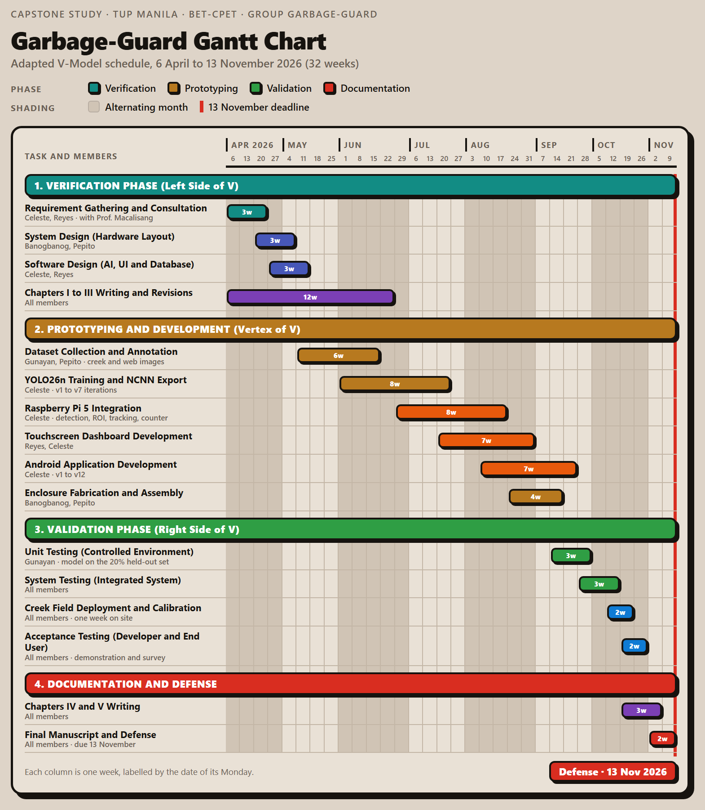

VIII. STUDENTS’ BIONOTE
Brian Jay Celeste, a student enrolled in Computer Engineering Technology at the TUP - Manila and achieved N3 certification in the Japanese Language Proficiency Test (JLPT). He works on software development, artificial intelligence, embedded systems, and electronics as his primary technical focus areas. The study designates him as the second project developer who develops the system architecture and trains the YOLO26 garbage detection model through computer vision, mainly focusing on Android App integration.
Genesis Walter D. Reyes II, a Computer Engineering Technology Student in Technological University of the Philippines. He mainly focuses on his interests in both hardware and software. The study designates him as the second project developer who is the main developer who trained the YOLO26 garbage detection model.
Jade C. Gunayan, a Computer Engineering Technology Student in Technological University of the Philippines. He conducts research testing and statistical analysis to verify the thesis prototype system's trustworthy performance.
King Perth G. Pepito, a Computer Engineering Technology student at the Technological University of the Philippines. His current research project work involves analyzing systems, designing organizational rules, and proofreading research documentation to guarantee the successful execution of the project.
Rodel S. Banogbanog, a Computer Engineering Technology student at TUP-Manila with interest in both hardware and software technologies, also achieved Certification of NCII of CSS and NCII of Electrical Installation. He focuses on creating intelligent systems through his development work. In this study, Banogbanog handles the project fabrication and design actualization.

